 | Autumn Term – Year 2
 | Autumn 1 | Autumn 2
 | Writing skills focus:  - Write for different purposes to develop my stamina  - Use thoughtful word choices. | Writing skills focus:  - Write for different purposes to develop my stamina  - Use thoughtful word choices.
 | Genre focus  Fiction: Stories with familiar settings  Non-fiction:  Poetry: | Genre focus  Fiction: Traditional tales  Non-fiction: Newspaper report  Poetry: Senses poetry
Core text | The Day the Crayons Quit  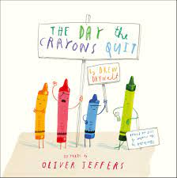 | 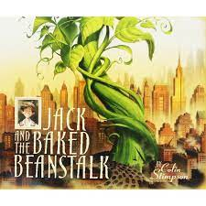  Jack and the Baked Beanstalk
Fiction | Stories with familiar settings | Traditional tales – write their own twisted tale
Non-fiction | Letters | Newspaper report
Poetry |  | Senses poetry (winter)
Hook ideas

Short burst writing opportunities | Characterisation  Switch the characters  Speech bubbles  Debates  Pros + cons  Hot seating | TV reports  Interviewing  Hot seating  Questioning  Note taking  Headlines  Character developing
Texts to enrich learning

Wider curriculum writing opportunities (if apt)
Bredbury 50 things links

 | Spring Term – Year 2
 | Spring 1 | Spring 2
 | Writing skills focus:  - Use expanded noun phrases to describe, expand and specify.  - Use subordination (when, if, that or because) | Writing skills focus:  - Plan writing by discussing the content of my writing (jotting down, orally rehearsing)  - Evaluate writing independently, with peers and with teacher, making simple corrections.
 | Genre focus  Fiction: Different stories by the same author  Non-fiction: Non-chronological report  Poetry: | Genre focus  Fiction: Journey story  Non-fiction: Diary entry  Poetry: Riddles
Core text | Books by Anthony Browne  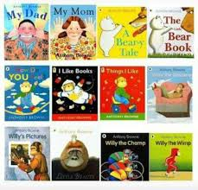 | Meerkat Mail Poetry: Crazy mayonaisy Mum  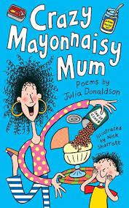  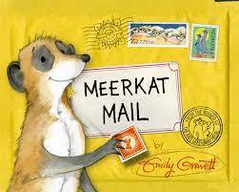
Fiction | Different stories by the same author | Journey story
Non-fiction | Non-chron report – fact file about Anthony Browne | Diary entry
Poetry
Hook ideas

Short burst writing opportunities | Book reviews  Compare stories  Explore pictures  Explore characters  Captions  Postcards | Letters  Postcards  E-mails  Photos and captions  Descriptions
Texts to enrich learning

Wider curriculum writing opportunities (if apt)
Bredbury 50 things links

 | Summer Term – Year 2
 | Summer 1 | Summer 2
 | Writing skills focus:  - Proof read to check for errors in spelling, grammar and punctuation.  - Use sentences including statements, questions, exclamations and commands.  - Use co-ordination (or, and, but)  - Use adjectives, adverbs and expanded noun phrases to add detail. | Writing skills focus:  - Make changes, sometimes independently, sometimes in discussion with an adult to improve effect and impact on my writing.  - Use present and past tense correctly  - Use adjectives, adverbs and expanded noun phrases to add detail.
 | Genre focus  Fiction: Fantasy story  Non-fiction: Explanation text  Poetry: | Genre focus  Fiction: Stories from other cultures  Non-fiction: Persuasive writing  Poetry: The works
Core text | Mr Majeka  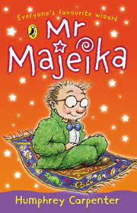 | 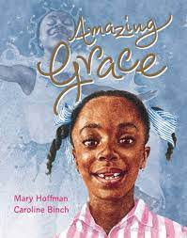  Amazing Grace
Fiction | Fantasy story | Stories from other cultures
Non-fiction | Explanation text – How to make Mr Majeka’s bike work | Persuasive writing – Why should Grace play Peter Pan?
Poetry |  | The Works (theme TBC)
Hook ideas

Short burst writing opportunities | Diagrams with labels  Human flow diagrams  Instruction writing  Cause and effect | What is your dream?  Rules  Debates  Visitors in  Gender stereotyping  Pros/cons
Texts to enrich learning

Wider curriculum writing opportunities (if apt)
Bredbury 50 things links

