 | Autumn Term – EYFS
 | Autumn 1 | Autumn 2
 | Writing skills focus:
 | Genre focus  Fiction: Stories with familiar settings  Poetry: Nursery rhymes | Genre focus  Non-fiction: Labels, lists and captions
Core text | The Train Ride by June Crebbin Old Macdonald had a farm  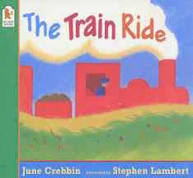  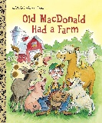 | Owl Babies by Martin Waddell  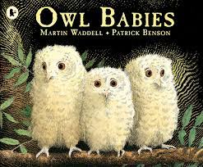
Fiction | Stories with familiar settings  SPAG links:
Non-fiction |  | Labels, lists and captions
Poetry | Nursery Rhymes
Hook ideas

Short burst writing opportunities | -Spine poem (I see…)  -Simple sentences (using train footage)  -Simple sentences (He had a…)  -Labelling (animals and the noises they make)  -Performing | -Thought bubbles  -Captioning pictures  -Labelling owl  -Christmas lists  -Christmas cards  -Name writing  -To...love from
Texts to enrich learning | Variety of other nursery rhymes
Wider curriculum writing opportunities (if apt)
Bredbury 50 things links

 | Spring Term – EYFS
 | Spring 1 | Spring 2
 | Writing skills focus:
 | Genre focus  Fiction: Traditional stories  Poetry: Patterns on the page | Genre focus  Non-fiction: Instructions
Core text | Billy Goats Gruff The little Puffin  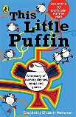  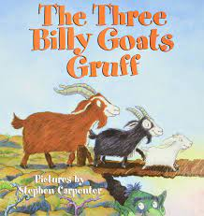 | 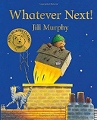  Whatever next On the way home  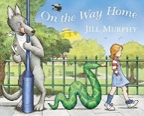
Fiction | Traditional stories
Non-fiction |  | Instructions
Poetry | Patterns on the page
Hook ideas

Short burst writing opportunities | -Character descriptions  -Setting description  -Thought bubbles  -Word play  -Rhyming strings  -Heavy oral focus | -Predictions  -Sequencing pictures  -Physically carrying out instructions  -Orally giving instructions
Texts to enrich learning

Wider curriculum writing opportunities (if apt)
Bredbury 50 things links

 | Summer Term – EYFS
 | Summer 1 | Summer 2
 | Writing skills focus:
 | Genre focus  Fiction: Different stories by the same author  Poetry: Senses | Genre focus  Fiction: Stories from other cultures
Core text | The Gruffallo Sharing a shell A treasury of songs  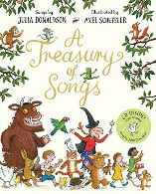  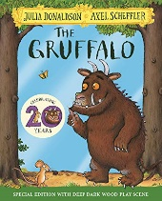  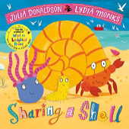 | Handa’s Surprise  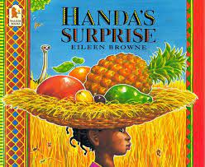
Fiction | Different stories by the same author | Stories from other cultures
Non-fiction
Poetry | Senses poetry
Hook ideas

Short burst writing opportunities | -Character descriptions  -Spine poems  -Exploring adjectives  -Senses walks  -Senses lists (I can see, I can hear) | -Fruit tasting  -Describe the fruit  -Orally retell journey  -Change the animals  -Setting description
Texts to enrich learning | Other stories by Julia Donaldson
Wider curriculum writing opportunities (if apt)
Bredbury 50 things links

