


MEDICINES IN SCHOOLS POLICY

School/Academy Name: Bredbury St Mark’s CE Primary School

Date agreed by LGB | Review Date | Signed Chair of LGB
20.10.22 | 20.10.23 | T. walker





Services to People
Supporting Pupil’s Medical Conditions in Schools Policy
Original May 2010
Revised January 2013/ May 2015/ February 2018
Reviewed by Bredbury St Marks July 2021 / September 2022
Contents

School Policy Record 1
Policy Statement 2
Policy Example and Guidelines 3
Medical Conditions Information Pathway 5
Administration – Emergency Medication 7
Administration – General 7
Use of ‘over the counter’ i.e. non-prescription medications 8
Guidelines for administering Paracetamol 9
Safe Storage – Emergency Medication 11
Safe Storage – Non-Emergency Medication 11
Safe Storage – General 11
Safe Disposal 12
Enrolment Forms 13
Individual Health Plans (Forms 1 – 1g) 13
School Individual Health Plan Register 14
On-going Communication and Review of Individual Health Plans 14
Storage and Access to Individual Health Plans 14
Use of Individual Health Plans 15
Consent to Administer Medicines 15
Residential Visits 15
Record of Awareness Raising Updates and Training 16
Physical Environment and Reasonable Adjustments 17
Social Interactions 17
Exercise and Physical Activity 17
Education and Learning 18
Risk Assessments 18
Reasonable Adjustments………………………………………………………………………………………………….………… 19
Governor Responsibilities 20
Headteacher Responsibilities 20
All School Staff and Support Staff Responsibilities 21
Teaching Staff Responsibilities 21
School Nurse or Healthcare Professional Responsibilities 22
First Aider Responsibilities 22
Special Educational Needs Coordinator Responsibilities 22
Pastoral Support Responsibilities 22
Pupil Responsibilities 22
Parents/Carers Responsibilities 23
Legislation and Guidance 24

APPENDICES 29
Form 1 - Individual Health Plan 30
Form 1a - Individual Health Plan – Diabetes 35
Form 1b - Individual Health Plan - Epilepsy 51
Action Plan for Allergic Reactions (EpiPen) 56
Action Plan for Allergic Reaction (JEXT) 57
Form 1d - Individual Health Plan - Asthma 58
Template Letter from School Nurse to Parent/Carer 61
Form 3a - Medication Permission & Record – Individual Pupil 62
Form 3b - Record of Medication 63
Form 4 - Staff Training Record 64
Form 5 - For Visits and Journeys 65
Giving Paracetamol in Stockport Schools 67
Verbal Consent from Parent / Carer 68
Emergency Procedures 69
How to Administer BUCCOLAM 70
Administration of Rectal Diazepam………………………………………………..…………72
Guidance for Schools on the use of Emergency Salbutamol Inhalers……………….....73
Asthma Emergency Procedures 74
Anaphylaxis Emergency Procedures 76
Diabetes Emergency Procedures 78
Epilepsy Emergency Procedures 80
Management of Needlestick/Sharp Injuries…………………………………………………83
Guidance on Infection Control in Schools…………………………………………………….. 84

School Policy Record

School Policy Agreed:

Reviewed: | July 2021
Designated Person: | Danielle Halfpenny / Louise Barrett
Governor with Remit:

Emergency Contacts for Staff: | Mrs Emma Harding (Headteacher): 0161 430-3418
First Aiders | The majority of our Teaching Assistants hold a First Aid Qualification. In addition to this:  - Kay Nicklin  - Allan Clayton  - Hayley Kaye  - Claire Oldham  - Sue Speck  are Paediatric trained.

Policy Statement

At Bredbury St Marks we are an inclusive community that aims to support and welcome pupils with medical conditions.

We aim to provide all pupils with all medical conditions the same opportunities as others at school.

We will help to ensure they can through the following:

- This school ensures all staff understand their duty of care to children and young people in the event of an emergency.

- All staff feel confident in knowing what to do in an emergency.

- This school understands that certain medical conditions are serious and can be potentially life threatening, particularly if ill managed or misunderstood.

- This school understands the importance of medication being taken as prescribed.

- All staff understand the common medical conditions that affect children/young people at this school. This school allows adequate time for staff to receive training on the impact medical conditions can have on pupils.

- Staff receive additional training about any children/young people they may be working with who have complex medical needs supported by an Individual Health Plan (IHP).

This policy is followed and understood by our school community, the Local Authority and Stockport Foundation Trust.

Policy Example and Guidelines

1. This school is an inclusive community that aims to support and welcome pupils with medical conditions.

- This school understands that it has a responsibility to make the school welcoming and supportive to pupils with medical conditions who currently attend and to those who may enrol in the future. In doing so, the school will work in partnership alongside the child’s parents/carers.

- This school aims to provide all children/young people with all medical conditions the same opportunities as others at school. We will help to ensure they can:

- be healthy
- stay safe
- enjoy and achieve
- make a positive contribution
- achieve economic well-being

- Pupils with medical conditions are encouraged to manage their condition.

- This school aims to include all pupils with medical conditions in all school activities wherever possible.

- Parents/carers of pupils with medical conditions are aware of the care their children/young people receive at this school.

- The school ensures all staff understand their duty of care to children and young people in the event of a medical emergency.

- All staff have access to information about what to do in a medical emergency.

- This school understands that medical conditions are serious and can be potentially life-threatening, particularly if ill managed or misunderstood.

- The School Nursing Service will offer schools an annual update. If a new medical condition arises over the year then the school nurse will provide an update or give advice on the most appropriate service to deliver it. THE HEADTEACHER IS RESPONSIBLE FOR ENSURING STAFF RECEIVE ANNUAL UPDATES.

- The Headteacher and Governing Body are responsible for ensuring the medical conditions policy is understood and followed by the whole school.

- This school understands and encourages the importance of immunisation and the role this has to play in ensuring a safe and inclusive school and will work in partnership with parents/carers and health professionals to this end.
2. The medical conditions policy is supported by a clear communication plan for staff, parents/carers and other key stakeholders to ensure its full implementation (see Medical Conditions Information Pathway below).

- Pupils are informed and reminded about the medical conditions policy:

- in personal, social and health education (PSHE) classes

- Parents/carers are informed about the medical conditions policy and that information about a child’s medical condition will be shared with the school nurse:

- by including a policy statement in the schools' prospectus and signposting access to the policy
- at the start of the school year when a communication is sent out about Individual Health Plans
- in the School Newsletter at intervals in the year
- when their child/young person is enrolled as a new pupil
- via the school's website, where it is available all year round

- School staff are informed and regularly reminded about the school’s medical conditions policy:

- through the staff handbook and staff meetings and by accessing the school website
- through medical conditions updates
- through the key principles of the policy being displayed in several prominent staff areas at this school and on the school’s intranet
- all supply and temporary staff are informed of the policy and their responsibilities including who is the designated person, any medical needs or Individual Health Plans related to the children/young people in their care and how to respond in emergencies
- Staff are made aware of Individual Health Plans as they relate to their teaching/supervision groups. This is a role for the designated person.

- School Governors should receive updates from the Local Authority if changes are made to the policy and ensure points a-c are met by the school.

Medical Conditions Information Pathway

Form sent out by school asking parents/carers to identify any medical conditions including:  - Transition discussions  - At start of school year  - New enrolment (during the school year)  - Parents/carers inform school of any new diagnosis, school then to inform school nurse | School

School and School Nurse collate response and identify those needing individual health plans | School

School Nurse contacts parents/carers to formulate new plan or review existing plan if necessary | School Nurse

School Nurse discusses new or reviewed IHP with designated person. Stored in school according to policy. | School Nurse & School

All parties to ensure IHP is in place. If there are any difficulties in getting this finalised, School Nurse to discuss with designated person. | School Nurse & School

Pupils with medical conditions requiring Individual Health Plans are: those who have diabetes, epilepsy with rescue medication, anaphylaxis, gastrostomy feeds, central line or other long term venous access, tracheostomy, severe asthma that has required an overnight hospital admission within the last 12 months. There may be other children/young people with unusual chronic conditions who need a care plan, please liaise with the School Nurse about them.

3. Relevant staff understand and are updated in what to do in a medical emergency for the most common medical conditions at this school.

a. Relevant staff at this school are aware of the most common medical conditions at this school.

b. Staff at this school understand their duty of care to pupils both during, and at either side of the school day in the event of a medical emergency. In any emergency situation school staff are required under common law duty of care to act like any reasonably prudent parent/carer. This may include administering medication. In the event of the child/young person attending a pre or after school activity organised by a private provider, the responsibility of sharing a child/young person’s medical needs is the responsibility of parents/carers.

c. Staff should receive updates at least once a year from the school nurse for asthma and other medical needs and know how to act in an emergency. Additional training is prioritised for key staff members who work with children/young people who have specific medical conditions supported by an Individual Health Plan.

d. The action required for staff to take in an emergency for the common conditions at this school is displayed in prominent locations for all staff including classrooms, kitchens, in the school staff room and electronically.

e. This school uses Individual Health Plans to inform the appropriate staff (including supply teachers and support staff) of pupils with complex medical needs in their care who may need emergency help.

f. This school has procedures in place so that a copy of the pupil’s Individual Health Plan is sent to the emergency care setting with the pupil. On occasions when this is not possible, the form is sent (or the information on it is communicated) to the hospital as soon as possible.

g. If a pupil needs to be taken to hospital, a member of staff will always accompany them and will stay with them until a parent/carer arrives. This school will try to ensure that the staff member will be one the pupil knows. The staff member concerned should inform a member of the schools senior management and/or the schools critical incidents team.

4. The school has clear guidance on the administration of medication at school.

Administration – Emergency Medication

- This school will seek to ensure that pupils with medical conditions have appropriate access to their emergency medication.

- This school will ensure that all pupils understand the arrangements for a member of staff (and the reserve member of staff) to assist in supporting and/or administering their emergency medication safely.

Administration – General

- This school understands the importance of medication being taken as prescribed.

- All use of medication is done under the appropriate supervision of a member of staff at this school unless there is an agreed plan for self-medication. If staff become aware pupils are using their medication in an abnormal way they should discuss this with the child/young person.

Important Note: Should staff become aware that a child/young person using their reliever (usually blue) inhaler more than three times a week or suddenly using their reliever inhaler more than they normally do, has asthma that may not be under control and may be at greater risk of having an asthma attack. Should this be observed, immediate action should be taken to alert the parents/carers and staff should record any actions or discussions.

- All staff are aware that there is no legal or contractual duty for any member of staff to administer medication or supervise a pupil taking medication unless they have been specifically contracted to do so or unless the situation is an emergency and falls under their regular duty of care arrangements.

- Many members of staff are happy to take on the voluntary role of administering medication. For medication where no specific training is necessary, any member of staff may administer medication to pupils under the age of 16, but only with the written consent of the pupil’s parent/carer (see form 3a).

- This school will ensure that specific training and updates will be given to all staff members who agree to administer medication to pupils if necessary.

- All school staff in this school have been informed through training that they are required, under common law duty of care, to act like any reasonably prudent parent/carer in an emergency situation. This may include taking action such as assisting in administering medication or calling an ambulance.

- In some circumstances, medication is only administered by an adult of the same gender as the pupil, and preferably witnessed by a second adult. This will be agreed in the Individual Health Plan.

- Parents/carers at this school understand that if their child/young person’s medication changes or is discontinued, or the dose or administration method changes, that they should notify the school immediately. Parents/carers should provide the school with any guidance regarding the administration of medicines and/or treatment from the GP, clinics or hospital. School should inform the school nurse should the IHP need to be amended.

- If a pupil at this school refuses their medication, staff will record this and contact parents/SLT immediately.

- All staff attending off-site visits are aware of any pupils on the visit who have medical conditions. They will receive information about the type of condition, what to do in an emergency and any other additional support necessary, including any additional medication or equipment needed.

- The needs of all pupils on trips and visits should be Risk Assessed and the pupil’s prescribed medication and spare inhaler, if necessary, should be taken and accessible.

- If a trained member of staff, who is usually responsible for administering medication, is not available the school explores possible alternative arrangements with parents/carers. This is always addressed in the risk assessment for off-site activities.

- If a pupil misuses medication or medical equipment, either their own or another pupil’s, their parents/carers are informed as soon as possible. The school will seek medical advice by ringing A+E if this situation arises. In such circumstances, pupils will be subject to the school’s usual disciplinary procedures.

- If the school receives a request or instruction from a parent/carer which would appear to be contrary to the advice in the document and from the DFE, the school should seek clarification from the parent/carer and any advice they can provide from consultants/clinicians associated with the pupil’s case and also contact School Support (0161 474 3917) / School Nurse (0161 835 6083) to discuss the matter before agreeing any further action.

Use of ‘over the counter’ i.e. non-prescription medications

There must be written parental consent for recurring ‘over the counter’ medications e.g. piriton for hayfever (form 3a).

Where a non-prescribed medicine is administered to a child/young person it should be recorded (form 3b) and the parents/carers informed.

Medication e.g. for pain relief, should never be administered without first checking the label for the appropriate dosage and checking when the previous dose was taken.

If a child/young person suffers regularly from frequent or acute pain the parents/carers should be encouraged to refer the matter to the child’s GP.

A child under 16 should never be given aspirin unless prescribed by a doctor.

Early Years providers should follow the EYFS guidance:

‘Medicines must not usually be administered unless they have been prescribed for a child/young person by a doctor, dentist, nurse or pharmacist (EYFS Statutory Guidance 2012).’

Guidelines for administering Paracetamol

Paracetamol is a widely used drug for controlling pain and reducing temperature. Despite its prevalence, it can be very dangerous if taken inappropriately. Overdose requires immediate medical attention.

The Local Authority, in consultation with health practitioners, has carefully considered the benefits and dangers of administering this non-prescription drug in schools and settings. Administering paracetamol to children under 5 is not usually recommended.

Early Years providers should follow the EYFS guidance:

‘Medicines must not usually be administered unless they have been prescribed for a child/young person by a doctor, dentist, nurse or pharmacist (EYFS Statutory Guidance 2012).’

For older pupils, it is sometimes appropriate to give paracetamol to control specific pain such as migraine or period pain. Schools administering paracetamol to children/young people should adhere to the following conditions:

The member of staff responsible for giving medicines must be wary of routinely giving paracetamol to children. If a child/young person complains of pain as soon as they arrive at school and asks for painkillers, it is not advisable to give paracetamol until the amount given over the past 24 hours has been established. No more than 4 doses should be given in a 24 hour period. There should be at least 4 hours between any 2 doses of paracetamol containing medicines. No more than 4 doses of any remedy containing paracetamol should be taken in any 24 hours. Always consider whether the child/young person may have been given a dose of paracetamol before coming to school. Many non-prescription remedies such as Beechams Powders, Lemsip, Night Nurse etc. contain paracetamol. If paracetamol tablets are taken soon after taking these remedies, it could cause an unintended overdose.

There must be parental consent to give paracetamol (appendix 6)

Paracetamol must be administered according to the instructions on the box or label. Stronger doses or combination drugs, which contain other drugs besides paracetamol must not be administered. It is recommended that the school keep its own stock of tablets. This reduces the risk of pupils carrying medicines.

Paracetamol must be stored securely and should not be kept in first aid boxes.

If it is the school's policy not to stock paracetamol, there must be a clear and safe arrangement for parents/carers to supply them to the school for the child/young person. It is not recommended to allow children/young people to carry paracetamol around.

Children/young people should only be given one dose during the school day. If this does not relieve the pain, contact the parent/carer or the emergency contact.

The member of staff responsible for giving medicines must witness the child/young person taking the paracetamol, and make a record of it (appendix 3b). The school must notify the parent/carer on the day, stating the time and the amount of the dose.

The pupil should be made aware that paracetamol should only be taken when absolutely necessary, that it is an ingredient in many cold and headache remedies and that great care should be taken to avoid overdosing.
5. This school has clear guidance on the storage of medication at school.

Safe Storage – Emergency Medication

- Emergency medication is readily available to pupils who require it at all times during the school day or at off-site activities. If the emergency medication is a controlled drug and needs to be locked up, the keys are readily available and not held personally by members of staff.

- If the pupil concerned is involved in extended school services then specific arrangements and risk assessments should be agreed with the parent/carer and appropriate staff involved.

- It is appropriate for a pupil to carry an adrenaline auto injector on their person in school after a risk assessment has been completed.

Safe Storage – Non-Emergency Medication

- All non-emergency medication is kept in a secure place, in a locked cupboard in a cool dry place. Pupils with medical conditions know where their medication is stored and how to access it.

- It is not appropriate for a pupil to carry insulin on their person in school. This should be stored in a locked cupboard.

- Staff ensure that medication is accessible only to those for whom it is prescribed.

Safe Storage – General

- This school has an identified member of staff/designated person who ensures the correct storage of medication at school. This is Danielle Halfpenny

- All controlled drugs are kept in a locked cupboard and only named staff have access. The staff are members of the Leadership Team and Danielle Halfpenny.

- The identified member of staff (Danielle Halfpenny) checks the expiry dates for all medication stored at school each term (i.e. three times a year).

- The identified member of staff, along with the parents/carers of pupils with medical conditions, ensures that all emergency and non-emergency medication brought into school is clearly labelled with the pupil’s name, the name of the medication, route of administration, dose and frequency, and expiry date of the medication.

- All medication is supplied and stored in its original containers. All medication is labelled with the pupil’s name, the name of the medication, expiry date and the prescriber’s instructions for administration, including dose and frequency.

- Medication is stored in accordance with the manufacturer’s instructions, paying particular note to temperature.

- Some medication for pupils at this school may need to be refrigerated. All refrigerated medication is stored in an airtight container and is clearly labelled. Refrigerators used for the storage of medication are inaccessible to unsupervised pupils or locked as appropriate. Medication fridges MUST only be used for the storage of medicines and no other items.

- All medication (including blue inhalers) and equipment such as spacers or blood sugar monitoring kits are sent home with pupils at the end of the school term.

- It is the parents/carer’s responsibility to ensure adequate supplies of new and in date medication comes into school at the start of each term with the appropriate instructions and ensures that the school receives this.

Safe Disposal

- Parents/carers at this school are asked to collect out-of-date medication.

- If parents/carers do not pick up out-of-date medication, or at the end of the school year, medication is taken to a local pharmacy for safe disposal with agreement from the local pharmacy.

- A named member of staff is responsible for checking the dates of medication and arranging for the disposal of any that have expired. This check is done at least 3 times a year and is always documented.

- Sharps boxes are used for the disposal of needles. Parents/carers obtain sharps boxes from the child’s GP or paediatrician on prescription. All sharps boxes in this school are stored in a locked cupboard unless alternative safe and secure arrangements are put in place on a case-by-case basis. Each box must be signed and dated as per assembly instructions, there should be one box per child and the temporary closure MUST be used when the box is not in use.

- If a sharps box is needed on an off-site or residential visit, a named member of staff is responsible for its safe storage and return to a local pharmacy, to school or to the pupil’s parent/carer.

- Disposal of sharps boxes - the sharps bin should be closed securely and returned to parents/carers. Parents/carers then need to take the sharps bin to the GP for disposal.
6. This school has clear guidance about record keeping for pupils with medical conditions.

Enrolment Forms

- Parents/carers at this school are asked if their child/young person has any medical conditions.

- If a pupil has a short-term medical condition that requires medication during school hours (e.g. antibiotics to cover a chest infection), a medication form plus explanation is sent to the pupil's parents/carers to complete (form 3a).

Individual Health Plans (Forms 1 – 1g)
Drawing up Individual Health Plans

- This school uses an Individual Health Plan for children/young people with complex medical needs to record important details about the individual children’s medical needs at school, their triggers, signs, symptoms, medication and other treatments. Further documentation can be attached to the Individual Health Plan if required (see form 1).

Examples of complex medical needs which may generate an Individual Health Plan following discussion with the school nurse and the school are listed below.

The child/young person has:
- diabetes
- gastrostomy feeds
- a tracheostomy
- anaphylaxis
- a central line or other long term venous access
- severe asthma that has required an overnight hospital admission within the last 12 months
- epilepsy with rescue medication.

- An Individual Health Plan, accompanied by an explanation of why and how it is used, is sent to all parents/carers of pupils with a complex medical need. This is sent by the school nurse:
- at the start of the school year
- at enrolment
- when a diagnosis is first communicated to the school
- transition discussions
- new diagnosis.

- It is the parents/carers responsibility to fill in the Individual Health Plan and return the completed form to the school nurse. If the school nurse does not receive an Individual Health Plan, all school staff should follow standard first aid measures in an emergency. The school will contact the parent/carer if health information has not been returned. If an Individual Health Plan has not been completed, the school nurse will contact the parents/carers and may convene a TAC meeting or consider safeguarding children/young people procedures if necessary.

- The finalised plan will be given to the parents/carers, school and school nurse.

- This school ensures that a relevant member of school staff is present, if required, to help draw up an Individual Health Plan for pupils with complex medical or educational needs.

School Individual Health Plan Register

- Individual Health Plans are used to create a centralised register of pupils with complex medical needs. An identified member of school staff has responsibility for the register at this school. Schools should ensure that there is a clear and accessible system for identifying pupils with health plans/medical needs such as names being 'flagged' on the SIMs system. A robust procedure should be in place to ensure that the child/young person's record, contact details and any changes to the administration of medicines, condition, treatment or incidents of ill health in the school are updated on the schools record system.

- The responsible member of school staff follows up with the parents/carers and health professional if further detail on a pupil's Individual Health Plan is required or if permission or administration of medication is unclear or incomplete.

On-going Communication and Review of Individual Health Plans

- Parents/carers at this school are regularly reminded to update their child/young person’s Individual Health Plan if their child/young person has a medical emergency or if there have been changes to their symptoms (getting better or worse), or their medication and treatments change. Each Individual Health Plan will have a yearly review date with the school nurse. The school should inform the school nurse of any changes to the IHP.

- Parents/carers should have a designated route/person to direct any additional information, letters or health guidance to in order that the necessary records are altered quickly and the necessary information disseminated.

Storage and Access to Individual Health Plans

- Parents/carers and pupils (where appropriate) at this school are provided with a copy of the pupil's current agreed Individual Health Plan.

- Individual Health Plans are kept in a secure central location at school.

- Apart from the central copy, specified members of staff (agreed by the pupil and parents/carers) securely hold copies of pupils’ Individual Health Plans. These copies are updated at the same time as the central copy. The school must ensure that where multiple copies are in use, there is a robust process for ensuring that they are updated, and hold the same information.

- When a member of staff is new to a pupil group, for example due to staff absence, the school makes sure that they are made aware of the Individual Health Plans and needs of the pupils in their care.

- This school ensures that all staff protect pupil confidentiality.

- This school informs parents/carers that the Individual Health Plan would be sent ahead to emergency care staff, should an emergency happen during school hours or at a school activity outside the normal school day. This is included on the Individual Health Plan.

- The information in the Individual Health Plan will remain confidential unless needed in an emergency.

Use of Individual Health Plans

Individual Health Plans are used by this school to:
- inform the appropriate staff about the individual needs of a pupil with a complex medical need in their care
- identify important individual triggers for pupils with complex medical needs at school that bring on symptoms and can cause emergencies. This school uses this information to help reduce the impact of triggers
- ensure this school’s emergency care services have a timely and accurate summary of a pupil’s current medical management and healthcare in an emergency

Consent to Administer Medicines

- If a pupil requires regular prescribed medication at school, parents/carers are asked to provide consent on their child/young person’s medication plan (form 3a) giving the pupil or staff permission to administer medication on a regular/daily basis, if required. This form is completed by parents/carers for pupils taking short courses of medication.

- All parents/carers of pupils with a complex medical need who may require medication in an emergency are asked to provide consent on the Individual Health Plan for staff to administer medication.

Residential Visits

- Parents/carers are sent a residential visit form to be completed and returned to school before their child/young person leaves for an overnight or extended day visit. This form requests up-to-date information about the pupil’s current condition and their overall health. This provides essential and up-to-date information to relevant staff and school supervisors to help the pupil manage their condition while they are away. This includes information about medication not normally taken during school hours (see appendix 5).

- All residential visit forms are taken by the relevant staff member on visits where medication is required. These are accompanied by a copy of the pupil’s Individual Health Plan.

- All parents/carers of pupils with a medical condition attending a school trip or overnight visit are asked for consent, giving staff permission to supervise administration of medication at night or in the morning if required.

- The residential visit form also details what medication and what dose the pupil is currently taking at different times of the day. It helps to provide up-to-date information to relevant staff and supervisors to help the pupil manage their condition while they are away (see appendix 5). A copy of the Individual Health Plan and equipment/medication must be taken on off-site activities.

- The residential visit/school trip form contains information on a pupil’s last tetanus immunisation. A copy of this form is required to be carried on any external visits.

Record of Awareness Raising Updates and Training

- This school holds updates on common medical conditions once a year. A record of the content and attendance of the medical condition training is kept by the school and reviewed every 12 months to ensure all new staff receive updates. The School Nursing Service will provide updates if the school request this.

- All school staff who volunteer or who are contracted to administer emergency medication are provided with training, if needed, by a specialist nurse, doctor or school nurse. The school keeps a register of staff who have had the relevant training; it is the school’s responsibility to arrange this (see appendix 4).

- School should risk assess the number of first aiders it needs and ensure the first aiders are suitably trained to carry out their responsibilities. It is recommended that Primary Schools and Early Years settings should have at least one first aider who has undertaken the paediatric first aid course. Training can be accessed through the St. John’s Ambulance http://www.sja.org.uk/sja/training-courses.aspx or may be provided centrally.

7. This school ensures that the whole school environment is inclusive and favourable to pupils with medical conditions. This includes the physical environment, as well as social, sporting and educational activities.

Physical Environment

- This school is committed to providing a physical environment that is as accessible as possible to pupils with medical conditions.

- Schools should be encouraged to meet the needs of pupils with medical conditions to ensure that the physical environment at this school is as accessible as possible.

- This school's commitment to an accessible physical environment includes out-of-school visits. The school recognises that this may sometimes mean changing activities or locations, or making reasonable adjustments to these arrangements which are proportionate and are implemented to remove any disadvantage that pupils may otherwise be subjected to because of their disability or medical condition, if it is serious.

Social Interactions

- This school ensures the needs of pupils with medical conditions are adequately considered to ensure their involvement in structured and unstructured social activities, including during breaks and before and after school.

- This school ensures the needs of pupils with medical conditions are adequately considered to ensure they have access to extended school activities such as school discos, breakfast clubs, school productions, after school clubs and residential visits.

- All staff at this school are aware of the potential social problems that pupils with medical conditions may experience. Staff use this knowledge to try to prevent and deal with problems in accordance with the school’s anti-bullying and behaviour policies.

- Staff use opportunities such as personal, social and health education (PSHE) lessons to raise awareness of medical conditions amongst pupils and to help create a positive social environment.

Exercise and Physical Activity

- This school understands the importance of all pupils taking part in physical education, sports, games and activities.

- This school seeks to ensure all classroom teachers, PE teachers and sports coaches make appropriate and proportionate adjustments to sports, games and other activities to make physical activity accessible to all pupils.

- This school seeks to ensure that all classroom teachers, PE teachers and sports coaches understand that if a pupil reports they are feeling unwell, the teacher should seek guidance before considering whether they should take part in an activity.

- Teachers and sports coaches are aware of pupils in their care who have been advised, by a healthcare professional, to avoid or to take special precautions with particular activities.

- This school ensures all PE teachers, classroom teachers and school sports coaches are aware of the potential triggers for pupils’ medical conditions when exercising and how to minimise these triggers.

- This school seeks to ensure that all pupils have the appropriate medication or food with them during physical activity and that pupils take them when needed.

- This school ensures all pupils with medical conditions are actively encouraged to take part in out-of-school clubs and team sports.

Education and Learning

- This school ensures that pupils with medical conditions can participate fully in all aspects of the curriculum and ensures that appropriate adjustments and extra support are provided in accordance with their needs or if there is an individual health plan (IHP) or education and health care plan (EHCP) in accordance with their agreed plan.

- Teachers at this school are aware of the potential for pupils with medical conditions to have special educational needs (SEN). Pupils with medical conditions who are finding it difficult to keep up with their studies are referred to the SEN coordinator.

- This school ensures that lessons about common medical conditions are incorporated into PSHE lessons and other parts of the curriculum.

- Pupils at this school learn how to respond to common medical conditions.

Risk Assessments

- Risk assessments are carried out by this school prior to any out-of-school visit or off site provision and medical conditions are considered during this process. This school considers: how all pupils will be able to access the activities proposed; how routine and emergency medication will be stored and administered, where help can be obtained in an emergency, and any other relevant matters.

- This school understands that there may be additional medication, equipment or other factors to consider when planning residential visits or off site activities. This school considers additional medication and facilities that are normally available at school. Where pupils medical needs require staff to attend specialist training, trained staff are available at all times and places (including evenings and weekends) where those pupils are participating.

- This school carries out risk assessments before pupils start any work experience or off-site educational placements. It is this school's responsibility to ensure that the placement is suitable, including travel to and from the venue for the pupil. Permission is sought from the pupil and their parents/carers before any medical information is shared with an employer or other education provider. Copies of Individual Health Care Plans are sent to off-site placements with parental consent.

Reasonable Adjustments

When considering the reasonableness or proportionality of making any adjustments this School will have regard to:

(1)The extent to which the adjustment removes the disadvantage,
(2)The extent to which it is practicable,
(3)The financial and other costs of making the adjustments,
(4)The extent to which the step would disrupt the school’s activities,
(5)The financial and other resources available to the school,
(6)The availability of external financial and other assistance,
(7)The nature of the school’s activities and the size of the undertaking,
(8)The level of disruption to other pupils and their needs or facilities.

In addition, if an adjustment is reasonable to apply then the school will not pass on the cost of making such an adjustment to the pupil or parents/carers.

8. Each member of the school and health community knows their roles and responsibilities in maintaining an effective medical conditions policy.

- This school works in partnership with all interested and relevant parties including the school’s governing body, school staff, and community healthcare professionals and any relevant emergency practitioners to ensure the policy is planned, implemented and maintained successfully.

- The following roles and responsibilities are used for the medical conditions policy at this school. These roles are understood and communicated regularly.

Governor Responsibilities
Governors have a responsibility to:
- Ensure the health and safety of their staff and anyone else on the premises or taking part in school activities (this includes all pupils). This responsibility extends to those staff and others leading activities taking place off-site, such as visits, outings or field trips.
- Ensure the schools health and safety policies and risk assessments are inclusive of the needs of pupils with medical conditions and reviewed annually.
- Make sure the medical conditions policy is effectively implemented, monitored and evaluated and regularly updated through a specified Governor’s Committee and/or Full Governing Body.
- Ensure that the school has robust systems for dealing with medical emergencies and critical incidents (see Stockport's Critical Incidents Guidelines), at any time when pupils are on site or on out of school activities.

Headteacher Responsibilities
The Headteacher has a responsibility to:
- Ensure the school is inclusive and welcoming and that the medical conditions policy is in line with local and national guidance and policy frameworks.
- Ensure the policy is put into action, with good communication of the policy to all teaching and non teaching staff, parents/carers and governors.
- Ensure every aspect of the policy is maintained.
- Ensure that if the oversight of the policy is delegated to another senior member of staff that the reporting process forms part of their regular supervision/reporting meetings.
- Monitor and review the policy at regular intervals, with input from governors, parents/carers, staff and external stakeholders.
- Report back to governors about implementation of the health and safety and medical conditions policy.
- Ensure through consultation with the governors that the policy is adopted and put into action.
- Ensure adequate numbers of first aiders and up to date training. All schools must have a least one paediatric trained first aider.

All School Staff and Support Staff Responsibilities
All School Staff and Support Staff have a responsibility to:
- Be aware of the potential triggers, signs and symptoms of common medical conditions and know what to do in an emergency.
- Call an ambulance in an emergency.
- Understand the school’s medical conditions policy.
- Know which pupils in their care have a complex medical need and be familiar with the content of the pupil’s Individual Health Plan.
- Know the schools registered first aiders and where assistance can be sought in the event of a medical emergency.
- Know the members of the schools Critical Incident Team if there is a need to seek assistance in the event of an emergency.
- Maintain communication with parents/carers including informing them if their child/young person has been unwell at school.
- Ensure pupils who need medication have it when they go on a school visit or out of the classroom.
- Be aware of pupils with medical conditions who may be experiencing bullying or need extra social support (School to add link to schools behaviour/anti bullying policy).
- Understand the common medical conditions and the impact these can have on pupils.
- Ensure that all pupils with medical conditions are not excluded unnecessarily from activities they wish to take part in.
- Ensure that pupils have the appropriate medication or food during any exercise and are allowed to take it when needed.
- Follow standard precautions if handling body fluids:
- https://www.gov.uk/government/uploads/system/uploads/attachment_data/file/522337/Guidance_on_infection_control_in_schools.pdf
- Ensure that pupils who presents as unwell should be questioned about the nature of their illness:
- if anything in their medical history has contributed to their current feeling of being unwell,
- if they have felt unwell at any other point in the day,
- if they have an Individual Health Plan and if they have any medication.
- The member of staff must remember that while they can involve the pupil in discussions regarding their condition, they are in loco parentis and as such must be assured or seek further advice from a registered first aider if they are in doubt as to the child/young person's health, rather than take the child/young person’s word that they feel better.

Teaching Staff Responsibilities
Have an additional responsibility to also:
- Ensure pupils who have been unwell have the opportunity to catch up on missed school work as appropriate.
- Be aware that medical conditions can affect a pupil’s learning and provide extra help when pupils need it, in liaison with the SENCO.
- Liaise with parents/carers, special educational needs coordinator and welfare officers if a child/young person is falling behind with their work because of their condition.
- If parent/carer can not be contacted, advise senior member of staff.
- Use opportunities such as PSHE and other areas of the curriculum to raise pupil awareness about medical conditions.

School Nurse or Healthcare Professional Responsibilities
The School Nurse or Healthcare Professional has a responsibility to:
- Offer annual updates for school staff in managing the most common medical conditions at school at the schools request. If a new medical condition arises over the year then the school nurse will provide an update or give advice on the most appropriate service to deliver it and provide information about where the school can access other specialist training.
- Update the Individual Health Plans when informed of a change in liaison with appropriate school staff and parents/carers.

First Aider Responsibilities
First Aiders have an additional responsibility to:
- Give immediate, appropriate help to casualties with injuries or illnesses.
- When necessary ensure that an ambulance is called.
- Ensure that their training is up to date and in line with the appropriate sector recommendations.
- It is recommended that first aiders are trained in paediatric first aid across the school.
- Schools should take note of the Early Years First Aid requirements.

Special Educational Needs Coordinator Responsibilities
Special Educational Needs Coordinators have the additional responsibility to:
- Ensure teachers make the necessary arrangements if a pupil needs special consideration or access arrangements in exams or coursework.

Pastoral Support Responsibilities
Pastoral Support have the additional responsibility to:
- Know which pupils have a medical condition and which have special educational needs because of their condition.
- Ensure all pupils with medical conditions are not excluded unnecessarily from activities they wish to take part in.

Pupil Responsibilities
Pupils have a responsibility to:
- Treat other pupils with and without a medical condition equally.
- Tell their parents/carers, teacher or nearest staff member when they are not feeling well.
- Let a member of staff know if another pupil is feeling unwell.
- Treat all medication with respect.
- Know how to gain access to their medication in an emergency.
- Ensure a member of staff is called in an emergency situation.
- Do not share or use medical equipment or medicines with other pupils.

Parents/Carers Responsibilities
Parents/Carers have a responsibility to:
- Tell the school if their child/young person has a medical condition or complex medical need particularly if there is a potential risk to their child/young person and/or other pupils.
- Ensure the school has a complete and up-to-date Individual Health Plan if their child/young person has a complex medical need.
- Inform the school about the prescribed medication their child/young person requires during school hours and before/after school activities/clubs.
- Inform the school/provider of any medication their child/young person requires while taking part in visits, outings or field trips and other out-of-school activities.
- Tell the school about any changes to their child/young person’s medication, what they take, when, and how much.
- Inform the school of any changes to their child/young person’s condition.
- Ensure their child/young person’s medication and medical devices are labelled with their child/young person’s full name.
- Ensure that the school has full emergency contact details for them.
- Provide the school with appropriate spare medication labelled with their child/young person’s name.
- Ensure that their child/young person’s medication is within expiry dates.
- Keep their child/young person at home if they are not well enough to attend school (refer to Public Health England guidelines and/or other specialist healthcare professionals).
- If there is an outbreak or specific risk of outbreak, then parents/carers must follow the guidance issued by the school (provided by professional bodies).
- Ensure their child/young person catches up on any relevant school work they have missed.
- Ensure their child/young person has regular reviews about their condition with their doctor or specialist healthcare professional.
- If the child/young person has complex medical needs, ensure their child/young person has a written Individual Health Plan for school.
- Have completed/signed all relevant documentation including form 3a and the Individual Health Plan if appropriate.
- Ensure that their child/young person is as up to date as possible with immunisations to ensure that both the school and its pupils are as safe as possible. If parents/carers do not wish to have their child/young person vaccinated then the school need to be made aware of this and a risk assessment of activities to be undertaken needs to be completed.

Legislation and Guidance

Introduction

- Local authorities, schools and governing bodies are all responsible for the health and safety of pupils in their care.
- Areas of legislation that directly affect a medical conditions policy are described in more detail in Managing Medicines in Schools and Early Years Settings (2005). The main pieces of legislation are the Equality Act (2010) and the Children & Families Act (2014). These acts make it unlawful for service providers, including schools, to discriminate against disabled people. Other relevant legislation includes the Education Act 1996, the Care Standards Act 2000, the Health and Safety at Work Act etc. 1974, the Management of Health and Safety at Work Regulations 1999 and the Medicines Act 1968.

This section outlines the main points from the relevant legislation and guidance that schools should consider when writing a medical conditions policy.

The following Stockport guidelines/policies need to be considered:-

- Department for Education and Department of Health Special Educational Needs and Disability Code of Practice 0-25 years.
- Stockport's STPD Health and Safety Policies
- Head Teachers Toolkit
- Critical Incidents Guidelines
- Visits and Journeys Guidelines
- Records Management and Retention Policies
- Reporting of Injuries, Diseases & Dangerous Occurrences Regulations. (R.I.D.D.O.R)

This form can be downloaded at:
http://intranet/smbcintr/new/content/directorates/bs/hr/shrfirst/documents/RIDDOR.pdf

Managing Medicines in Schools and Early Years Settings (2005)

This provides guidance from the DFE on managing medicines in schools and early year’s settings. The document includes the following chapters:

- developing medicines policies
- roles and responsibilities
- dealing with medicines safely
- drawing up an Individual Health Plan
- relevant forms.

Medical Conditions at School: A Policy Resource Pack is designed to work alongside Managing Medicines in Schools and Early Years Settings.

Equality Act (2010) (EA) and The Children and Families Act 2014 (CFA).

- Many pupils with medical conditions are protected by the EA and CFA, even if they don’t think of themselves as ‘disabled’.
- The Equality and Human Rights Commission (EHRC) (previously the Disability Rights Commission) publishes a code of practice for schools, which sets out the duties under the EA and gives practical guidance on reasonable adjustments and accessibility. The EHRC offers information about who is protected by the EA, schools’ responsibilities and other specific issues.

Schools’ Responsibilities Include:

- Not to treat any pupil less favourably in any school activities without material and sustainable justification.
- To make reasonable adjustments that cover all activities – this must take into consideration factors such as financial constraints, health and safety requirements and the interests of other pupils. Examples of reasonable adjustments can be found in the Department for Education & Department of Health Special Educational Needs and Disability Code of Practice 2015 and is dealt with here on page 19. *
- To eliminate discrimination and promote equality of opportunity in accordance with the provisions of Section 149 of the Equality Act 2010, which came in to force on 5 April 2011 relating to the public sector equality duty.
- To promote disability equality in line with the guidance provided by the DFE and EHRC through the Disability Equality Scheme.
*DfES publications are available through the DFE.

The Education Act 1996

Section 312 of the Education Act covers children/young people with special educational needs, the provisions that need to be made and the requirements local health services need to make to help a local authority carry out its duties.

The Care Standards Act 2000

This act covers residential special schools and responsibilities for schools in handling medicines.

Health and Safety at Work Act etc. 1974

This act places duties on employers for the health safety and welfare of their employees and anyone not in their employment who may be affected by the activity. This covers the head teacher and teachers, non-teaching staff, pupils, visitors and contractors.

Management of Health and Safety at Work Regulations 1999

These regulations require employers to carry out risk assessments, manage the risks identified and to communicate these risks and measures taken to employees.

Medicines Act 1968

This act specifies the way that medicines are prescribed, supplied and administered.

Additional Guidance

Other guidance resources that link to a medical conditions policy include:

- Department for Education & Department of Health Special Educational Needs and Disability Code of Practice 2015.
- Equality Act 2010: Advice for Schools.
- Reasonable Adjustments for disabled pupils (2012).
- Supporting pupils at school with medical conditions (2014).
- The Mental Capacity Act Code of Practice: Protecting the vulnerable (2005).
- Every Child Matters: Change for Children (2004). The 2006 Education Act ensures that all schools adhere to the five aims of the Every Child Matters agenda.
- National Service Framework for Children and Young People and Maternity Services (2004) – provides standards for healthcare professionals working with children and young people including school health teams.
- Health and Safety of Pupils on Educational Visits: A Good Practice Guide (2001) – provides guidance to schools when planning educational and residential visits.
- Misuse of Drugs Act 1971 – legislation on the storage and administration of controlled medication and drugs.
- Home to School Travel for Pupils Requiring Special Arrangements (2004) – provides guidance on the safety for pupils when travelling on local authority provided transport.
- Including Me: Managing Complex Medical Needs in School and Early Years Settings (2005).
- Medical Conditions at School Website - http://medicalconditionsatschool.org.uk/
- Managing Medicines and Providing Medical Support in Schools and Early Years Settings UNISON - http://www.unison.org.uk/file/A14176.pdf

Further Advice and Resources

The Anaphylaxis Campaign
PO Box 275
Farnborough
Hampshire GU14 6SX
Phone 01252 546100
Fax 01252 377140
info@anaphylaxis.org.uk
www.anaphylaxis.org.uk

Asthma UK
18 Mansell Street
London E1 8AA
Helpline 0300 222 5800
Phone 020 7786 4900
Fax 020 7256 6075
info@asthma.org.uk
www.asthma.org.uk

Diabetes UK
Wells Lawrence House 126 Back Church Lane
London E1 1FH
Phone 0345 123 2399*Fax 020 7424 1001
info@diabetes.org.uk
www.diabetes.org.uk

Diabetes UK North West
First floor, The Boultings
Winwick Street
Warrington
Cheshire WA2 7TT
Phone 01925 653281
Fax 01925 653288
n.west@diabetes.org.uk

Epilepsy Action
New Anstey House
Gate Way Drive
Yeadon
Leeds LS19 7XY
Phone 0113 210 8800
Fax 0113 391 0300
epilepsy@epilepsy.org.uk
www.epilepsy.org.uk

Long-Term Conditions Alliance
202 Hatton Square
16 Baldwins Gardens
London EC1N 7RJ
Phone 020 7813 3637
Fax 020 7813 3640
info@ltca.org.uk
www.ltca.org.uk

Department for Education
Sanctuary Buildings
Great Smith Street
London SW1P 3BT
Phone 0870 000 2288
Text-phone/Minicom 01928 794274
Fax 01928 794248
info@dcsf.gsi.gov.uk
www.dcsf.gov.uk

Council for Disabled Children
National Children’s Bureau
8 Wakley Street
London EC1V 7QE
Phone 020 7843 1900
Fax 020 7843 6313
cdc@ncb.org.uk
www.ncb.org.uk/cdc

National Children’s Bureau
8 Wakley Street
London EC1V 7QE
Phone 020 7843 6000
Fax 020 7278 9512
www.ncb.org.uk

Health Protection Team
Public Health
Upper Ground Floor
Stopford House
Stockport SK1 3XE
Phone 0161 474 2440
healthprotection@stockport.gov.uk

PHE Health Protection Team
0344 225 0562 Option 1
www.gov.uk/government/organisations/public-health-england

APPENDICES

APPENDICES 29
Form 1 - Individual Health Plan 30
Form 1a - Individual Health Plan – Diabetes 35
Form 1b - Individual Health Plan - Epilepsy 51
Action Plan for Allergic Reactions (EpiPen) 56
Action Plan for Allergic Reaction (JEXT) 57
Form 1d - Individual Health Plan - Asthma 58
Template Letter from School Nurse to Parent/Carer 61
Form 3a - Medication Permission & Record – Individual Pupil 62
Form 3b - Record of Medication 63
Form 4 - Staff Training Record 64
Form 5 - For Visits and Journeys 65
Giving Paracetamol in Stockport Schools 67
Verbal Consent from Parent/Carer 68
Emergency Procedures 69
How to Administer BUCCOLAM 70
Administration of Rectal Diazepam…………………………………………………..………72
Guidance for Schools on the use of Emergency Salbutamol Inhalers…..…………… 73
Asthma Emergency Procedures 74
Anaphylaxis Emergency Procedures 76
Diabetes Emergency Procedures 78
Epilepsy Emergency Procedures 80
Management of Needlestick/Sharp Injuries………………………………………………... 83
Guidance on Infection Control in Schools…………………………………………………. 84



Form 1 - Individual Health Plan
For pupils with complex medical needs at school
Date form completed:
Date for review:
Reviewed by |  |  | Date  (dd/mm/yyyy) | Changes to Individual Health Plan
 |  |  |  | Yes No
 |  |  |  | Yes No
 |  |  |  | Yes No
Copies held by:
1. Pupil’s Information
Name of School:
Name of Pupil:
Class/Form
Date of Birth: |  | Male  Female
2. Contact Information
Pupil’s Address |  | Postcode:
Family Contact Information
a. | Name:
a. | Phone (Day):
a. | Phone (Evening):
a. | Mobile:
a. | Relationship with child/young person:
b. | Name:
b. | Phone (Day):
b. | Phone (Evening):
b. | Mobile:
b. | Relationship with child/young person:
GP
Name:
Phone:
Specialist Contact
Name:
Phone:
Medical Condition Information
3. Details of Pupil’s Medical Conditions
Signs and symptoms of this pupil’s condition:
Triggers or things that make this pupil’s condition/s worse:
4. Routine Healthcare Requirements
(For example, dietary, therapy, nursing needs or before physical activity)
During school hours:
Outside school hours:
5. What to do in an Emergency
Signs & Symptoms
In an emergency, do the following:

6. Emergency Medication
(Please complete even if it is the same as regular medication)
Name/type of medication
(as described on the container):
How the medication is taken and the amount:
Are there any signs when medication should not be given?
Are there any side effects that the school needs to know about?
Can the pupil administer the medication themselves?  (please tick box) |  | Yes No Yes, with supervision by:  Staff members name:
Is there any other follow-up care necessary?
Who should be notified?  (please tick box) |  | Parents Carers  Specialist GP
7. Regular Medication taken during School Hours
Name/type of medication (As described on the container):
Dose and method of administration
(The amount taken and how the medication is taken, e.g. tablets, inhaler, injection)
When it is taken (Time of day)?
Are there any side effects that could affect this pupil at school?
Are there are any contraindications (Signs when this medication should not be given)?
Self-administration: can the pupil administer the medication themselves? |  | (Tick as appropriate)  Yes No Yes, with supervision by:  Staff member’s name:
Medication expiry date:
8. Regular Medication taken outside of School Hours
(For background information and to inform planning for residential trips)
Name/type of medication (as described on the container):
Are there any side effects that the school needs to know about that could affect school activities?
9. Members of Staff Trained to Administer Medications for this Pupil
Regular medication:
Emergency medication:
10. Any Other Information Relating to the Pupil’s Healthcare in School?
Parental and Pupil Agreement
I agree that the medical information contained in this plan may be shared with individuals involved with my/my child/young person’s care and education (this includes emergency services). I understand that I must notify the school of any changes in writing.
Signed (Pupil)
Print Name:
Date:
Signed (Parent/Carer)
(If pupil is below the age of 16)
Print Name:
Date:
Healthcare Professional Agreement
I agree that the information is accurate and up to date.
Signed:
Print Name:
Job Title:
Date:

Permission for Emergency Medication
I agree that I/my child/young person can be administered my/their medication by a member of staff in an emergency
I agree that my child/young person cannot keep their medication with them and the school
will make the necessary medication storage arrangements
I agree that I/my child/young person can keep my/their medication with me/them for use when necessary
Name of medication carried by pupil:
Signed (Parent/Carer)
Date
Headteacher Agreement
It is agreed that (name of child/young person):
will receive the above listed medication at the above listed time (see part 7).
will receive the above listed medication in an emergency (see part 6).
This arrangement will continue until:
(Either end date of course of medication or until instructed by the pupil’s parents/carers).
Signed (Headteacher):
Print Name:
Date:

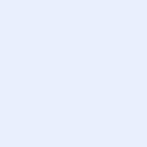 | 

INDIVIDUAL HEALTH CARE PLAN FOR A CHILD OR
YOUNG PERSON IN THE EDUCATION SETTING WHO HAS DIABETES

Contents:

Definitions………………………………………………………………………………………………..36
Child/Young Person’s Information…………………………………………………………………..37
Monitoring Blood Glucose Levels…………………………………………………………………...38
Insulin Administration with Meals……………………………………………………………………39
Insulin Administration………………………………………………………………………………….39
Suggested Daily Routine………………………………………………………………………………40
Sporting Activity/Day Trips & Residential Visits…………………………………………………..40
Hypoglycaemia…………………………………………………………………………………………..41
Hyperglycaemia………………………………………………………………………………………….44
References………………………………………………………………………………………………..50
This health care plan will capture the key information and actions that are required to support this child or young person (CYP) in school. It will have the CYP best interests in mind and ensure that school assesses and manages risks to the pupils’ education, health and social well-being and minimize disruption in the school day. It should be reviewed at least annually.

Definitions
IHCP  CYP  HYPO  CHO  BG | Individual Health Care Plan  Child or Young Person  Hypoglycaemia  Carbohydrate  Blood Glucose

CHILD/YOUNG PERSON’S INFORMATION

Child / Young Person Details
Child’s Name: |  |  |  | Year group:
Hospital/NHS number: |  |  |  | DoB:
Nursery/School/College:
Post code
Child’s Address:
Town:
County:
Postcode
Type of Diabetes:
Other medical conditions:
Allergies:
Date: |  | Document to be Updated:

Family Contact Information
Name
Relationship
Telephone Number | Home
Telephone Number | Work
Telephone Number | Mobile
Email
Name
Relationship
Telephone Number | Home
Telephone Number | Work
Telephone Number | Mobile
Email
Name
Relationship
Telephone Number | Home
Telephone Number | Work
Telephone Number | Mobile
Email

Essential Information Concerning This Child /Young Persons Health Needs

Contacts |  | Contact Number
Children’s Diabetes Nurses:
Key Worker:
Consultant Paediatrician:
General Practitioner:
Link Person in Education:
School email contact:
Class Teacher:
Health Visitor/School Nurse:
SEN Co-ordinator:
Other Relevant Teaching Staff:
Other Relevant Non-Teaching Staff:
Head teacher:

This CYP has DIABETES, requiring treatment with (check which applies):
Multi-dose regime i.e. requires insulin with all meals:
Insulin Pump Therapy:
3 injections a day (no injections in school):
2 injections a day (no injections in school):
Other - please state:

Pupils with Diabetes will have to attend clinic appointments to review their condition. Appointments are typically every 3 months, but may be more frequent .These appointments may require a full day’s absence. Education authority staff should be released to attend the necessary diabetes training sessions, in accordance with national guidance.

MONITORING BLOOD GLUCOSE LEVELS
The CYP has a blood glucose monitor, so they can check their blood glucose (BG). BG monitoring is an essential part of daily management; where ever possible CYP should be encouraged to take responsibility for managing their own medicines and BG equipment in school. They should be allowed to carry their equipment with them at all times and their equipment must not be shared.
(Check which applies)

BG checks to be carried out by a trained adult, using a Fastclix / Multiclix device.
This child/young person requires supervision with blood glucose monitoring.
This CYP is independent in BG monitoring.

This procedure should be carried out:
- In class or if preferred, in a clean private area with hand washing facilities.
- Hands to be washed prior to the test.
- Blood glucose targets pre meal - mmol/L and - mmol/L 2 hours after meals
(NICE guidelines 2015 recommend BG levels of 4-7 mmol/L pre meal and 5-9 mmol/L post meals)
- Lancets and blood glucose strips should be disposed of safely.
There are a wide range of different blood glucose meters available, some have a built in automated bolus calculator.

INSULIN ADMINISTRATION WITH MEALS
Check if applies if not, go to section 5

(Check which applies)
Insulin to be administered by a suitably trained adult, using a pen needle that complies with national and local sharps policy
Supervision is required during insulin administration
This young person is independent, and can self-administer the insulin
This CYP is on an insulin pump (see further information below and section 8.2 page 8)

The child or young person requires variable amounts of quick acting Insulin, depending on how much they eat.
(Check which applies)
They have a specific Insulin to carbohydrate (CHO) ratio ( I:C)
They are on set doses of insulin
This procedure should be carried out:
- In class, or if preferred in a clean private area with hand washing facilities
- Should always use their own injection device; or sets.
- All used needles should be disposed of in accordance with the school’s local policy

INSULIN ADMINISTRATION
Delivered via pen device: Delivered via insulin pump:

Insulin Name | Time | Process
Other:
Insulin Name | Time | Process
Other :
Insulin Name | Time | Process
Other :
Insulin Name | Time | Process
Other :
Insulin Name | Time | Process
Other :
NOTE: See 8

SUGGESTED DAILY ROUTINE
 | Time | Note
Arrive School
Morning Break
Lunch
Afternoon Break
School finish
Other
Please refer to ‘Home-school’ communication diary
Please refer to School planner

SPORTING ACTIVITY/ DAY TRIPS AND RESIDENTIAL VISITS
Governing bodies should ensure that risk assessments, planning and arrangements are clear to ensure this CYP has the opportunity to participate in all sporting activities. School should ensure reasonable adjustments as required.

Specific instructions If on Insulin Pump therapy: During contact sports the pump should be disconnected
(NEVER exceed 60 minutes). Please keep safe whilst disconnected.

Extra Snacks are required:
PRE-EXERCISE

POST-EXERCISE

HYPOGLYCAEMIA
(‘Hypo’ or ‘Low Blood Glucose’)
BG: Below 4 mmol/l.
INDIVIDUAL HYPO- SYMPTOMS FOR THIS CYP ARE: | Pale |  | Poor Concentration |  | Other:
INDIVIDUAL HYPO- SYMPTOMS FOR THIS CYP ARE: | Sudden Change of personality |  | Sleepy |  | Other:
INDIVIDUAL HYPO- SYMPTOMS FOR THIS CYP ARE: | Crying |  | Shaking |  | Other:
INDIVIDUAL HYPO- SYMPTOMS FOR THIS CYP ARE: | Moody |  | Visual changes |  | Other:
INDIVIDUAL HYPO- SYMPTOMS FOR THIS CYP ARE: | Hungry |  |  |  | Other:
How to treat a hypo:
- If possible, check BG to confirm hypo, and treat promptly: see 8a.
- Do not send this child or young person out of class unaccompanied to treat a hypo.
- Hypos are described as either mild/moderate or severe depending on the individual’s ability to treat him/her.
- The aim is to treat, and restore the BG level to above mmol/L. ( ISPAD guidelines recommend 5.6mmol/L) (See 8a).

A Hypo box should be kept in school containing fast acting glucose and long acting carbohydrate. Staff, and the CYP should be aware of where this is kept and it should be taken with them around the school premises; if leaving the school site; or in the event of a school emergency. It is the parent’s/carers responsibility to ensure this emergency box is adequately stocked; independent young people will carry hypo remedies with them.

Treatment of Hypoglycaemia
BG below 4mmol/l
Personalised Treatment Plan
Follow steps 1-4
Step 1. Give fast acting rapidly absorbed simple CHO promptly.
Step 2. Re-measure BG 15 minutes later
Step 3. If BG still below mmol/l:
Repeat step 1

If BG above mmol/l:
Step 4
For some CYP an extra snack may be required (especially if the next meal is 1-2 hours away)

Step 1

MILD/ MODERATE

Can he/she eat & drink independently?

Step 4

Personalised Treatment Plan
- Place the CYP in the recovery position
- Nil by mouth
- DIAL 999
- In exceptional circumstances, in the availability of a trained and competent member of staff : they can administer the Glucagon/ GlucaGen Hypokit injection:
0.5mg (half dose) for less than 8 years old (or body weight is less than 25kg)
1mg (full dose): if over 8 years of age.
- Never leave him/her alone
- Contact parents/carers.
- When fully awake follow steps 1-4 above.
- A severe hypo may cause vomiting.
- On recovery the CYP should be taken home by parents/carers.

SEVERE

Is he/she semi-conscious; unconscious; convulsing or unable to take anything by mouth?

Yes

Additional information regarding hypoglycaemia for this CYP:
*** Consider what has caused the HYPO? ***

HYPERGLYCAEMIA
(High blood glucose)

Children and young people who have with diabetes may experience high blood glucose (hyperglycaemia) when the blood glucose levels are above mmol/L.

*** IF THIS CYP IS ON INSULIN PUMP THERAPY PLEASE REFER DIRECTLY TO 9b ***

If the child/young person is well, there is no need for them to be sent home, but parents/guardian should be informed at the end of the day that the child/young person has had symptoms of high blood glucose

Treatment of Hyperglycaemia For A Child/Young Person On Injections

Encourage sugar free fluids
Allow free access to toilet
No exercise
If available test blood ketone levels
Re-test BG in 1 hour
If still above mmol/l:
Contact Parents/carers, he/she may well require extra fast acting insulin, consider a correction dose.

BG above mmol/l

No other symptoms

If correction dose is required:
1 unit of insulin will lower BG by mmol/l

If now below mmol/l:
Test BG before next meal

CONTACT PARENTS/CARERS IMMEDIATELY
Check blood ketone levels( see 9c)
Will require extra quick acting insulin
Needs to be taken home immediately.

BG above mmol/l

Feels unwell?
Headache
Abdominal pain
Sickness or
Vomiting

Ketones rising or symptoms worsening
Dial
999

Additional information regarding hyperglycaemia for this CYP:

Treatment of Hyperglycaemia for a Child/Young Person on Pump Therapy

BG above mmol/L
BG above mmol/L
Give correction dose via pump.

APPEARS WELL
- Check blood ketones
- Give correction bolus via the pump
- Encourage fluids
- Check pump and site
CYP UNWELL
- Drowsy
- Vomiting
- Not drinking
- Breathing Heavily

Dial
999 &
Contact parents

KETONES
ABOVE: mmol/L
(See 9c)

BLOOD KETONES
BELOW
0.6mmol/L

BG above: mmol/L

- Contact parents/carers whom will advise.
- Give insulin injection via a pen device
- Re site insulin pump set and reservoir by parent or in exceptional circumstances by, suitably trained member of staff.
- Monitor closely until parents/carers take home
BG below
mmol/L and falling
Continue to monitor 2 hourly.

RE-TEST BG IN ONE HOUR

9c. Blood β –Ketone monitoring Guide:
- Below 0.6mmol/L Normal range
- Between 0.6-1.5mmol/L Potential problems - SEEK ADVICE
- Above 1.5mmol/L High risk - SEEK UGENT ADVICE
Additional information regarding β Blood –Ketone monitoring for this CYP:

- School to be kept informed of any changes in this child or young person’s management (see page 6-7).
- The CYP with diabetes may wear identification stating they have diabetes. These are in the form of a bracelet, necklace, watch or medical alert card.
- During EXAMS, reasonable adjustments should be made to exam and course work conditions if necessary, this should be discussed directly with this CYP.
This CYP should be allowed to take into the exam the following: blood glucose meter, extra snacks; medication and hypo treatment.
- Specific extra support may be required for the CYP who has a long term medical condition regarding educational, social and emotional needs- for example, during periods of instability, during exams, catching up with lessons after periods of absence, and counselling sessions.
Please use the box below for any additional information for this CYP, and document what is specifically important for him/her:

This IHCP has been initiated and updated in consultation with the CYP, family; diabetes specialist nurse and a member of staff from the educational setting.

Name Signatures Date
Young person
Parents/carers
Parents/carers agreement to administration of medicine as documented on page 3 and 4
Diabetes Nurse Specialist:
School Representative:
Health visitor/ School Nurse:
The following should always be available in school, please check:
Hypo treatment: fast acting glucose |  | Insulin pen and appropriate pen needles.
Gluco gel/ Dextrogel |  | Cannula and reservoir for pump set change
Finger prick device, BG monitor and strips |  | Spare battery
Ketone testing monitor and strips |  | Up to date care plan
Snacks

Governing bodies are responsible to ensure adequate members of staff have received suitable training.
Training log:
Staff Name | Training Delivered | Trainer | Date

**See Training Log in school**

References:
- Supporting pupils at school with medical conditions. Department of Education. September 2014.
- NICE clinical guideline NG18: Diabetes (type 1 and type 2) in children and young people, diagnosis and management.. August 2015
- Managing Medicines in School and Early Years Setting. Department of Health. 2005
- ISPAD Clinical Practice Consensus Guidelines. 2014
- Making Every Young Person With Diabetes Matter. Department of Health. 2007.
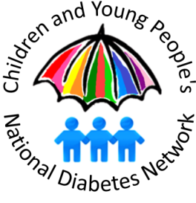

THIS CARE PLAN HAS BEEN DESIGNED BY A SUB-GROUP LEAD BY
Sandra Singleton, Children and Young People’s Diabetes Specialist Nurse/ Team Leader. With
Margot Carson, Children and Young People's Diabetes Network Coordinator - North West of England
Elaine McDonald, Children and Young People’s Diabetes Specialist Nurse/ Team Leader.
Dawn Anderson Children’s and Young people’s Diabetes Specialist Nurse
Linda Connellan, Children and Young People’s Diabetes Specialist Nurse
Jill Cullen, Specialist Community Practitioner School Nursing
Jayne Johnson, Staff Nurse School Nursing.
Helen Nurse Families with Diabetes National Network
Paula Maiden Families with Diabetes National Network
Daniel Hyde IT technical support

Acknowledgments:
The sub-group from the ‘Children and Young People’s North West Diabetes Network’ would like to thank the following regional ‘Children and Young People’s Diabetes Network’ teams for their helpful advice, support and input in the development of this document:

Birmingham Children’s Hospital
Cambridge University Hospitals NHS Foundation Trust
Chelsea & Westminster NHS Foundation Trust
Glangwili General Hospital
Leeds Children’s Hospital
North Somerset Community Partnership
North Tyneside General Hospital
Nottingham Teaching Hospitals NHS Trust
Oxford University Hospitals NHS Foundation Trust
Salisbury District Hospital

Review date: January 2018.

Copyright © 2016 National Children and Young People’s Diabetes Network

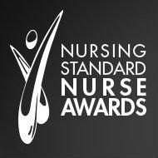

Winner of the Excellence in Diabetes Specialist Nursing Awards
At the Nurse Standard Nurse Awards 2015.

Form 1b - Individual Health Plan - Epilepsy
For pupils diagnosed with Epilepsy at school who need rescue medication
Date form completed:
Date for review:
Reviewed by |  |  | Date  (dd/mm/yyyy) | Changes to Individual Health Plan
 |  |  |  | Yes No
 |  |  |  | Yes No
 |  |  |  | Yes No
Copies held by:
1. Pupil’s Information
Medical Condition:
Name of School:
Name of Pupil:
Class/Form
Date of Birth: |  | Male  Female
2. Contact Information
Pupil’s Address: |  | Postcode:
Family Contact Information
a. | Name:
a. | Phone (Day):
a. | Phone (Evening):
a. | Mobile:
a. | Relationship with child/young person:
b. | Name:
b. | Phone (Day):
b. | Phone (Evening):
b. | Mobile:
b. | Relationship with child/young person:
Specialist Contact
Name:
Phone:
Consultant
Name:
Phone:

Medical Condition Information
3. Details of Pupil’s Medical Conditions - Seizure Description
Type 1
Type 2
Type 3
Triggers or things that make this pupil’s condition/s worse:
4. Routine Healthcare Requirements
(for example, dietary, therapy, nursing needs or before physical activity)
Routine Requirements
Record any seizures on the daily seizure record
5. What to do in an Emergency
Emergency Procedures
6. Emergency Medication
(Please complete even if it is the same as regular medication)
Name/type of medication (as described on the container):
Describe what signs or symptoms indicate an emergency for this pupil:
Dose and method of administration (how the medication is taken and the amount)
Are there any contraindications (signs when medication should not be given)?
Are there any side effects that the school needs to know about?
Self-administration: |  | Can the pupil administer the medication themselves?  (Tick as appropriate)  Yes No Yes, with supervision by:  Staff member’s name:
Is there any other follow-up care necessary?
Who should be notified? |  | Parents Carers  Specialist GP
7. Regular Medication taken during School Hours
Name/type of medication (As described on the container):
Dose and method of administration
(The amount taken and how the medication is taken, e.g. tablets, inhaler, injection)
When it is taken (Time of day)?
Are there any side effects that could affect this pupil at school?
Are there are any contraindications (Signs when this medication should not be given)?
Self-administration: can the pupil administer the medication themselves? |  | (Tick as appropriate)  Yes No Yes, with supervision by:  Staff member’s name:
Medication expiry date:
8. Regular Medication Taken Outside of School Hours
(For background information and to inform planning for residential trips)
Name/type of medication (as described on the container)
Are there any side effects that the school needs to know about that could affect school activities?
9. Any other information relating to the pupil’s healthcare in schools
Permission for Emergency Medication
I agree that I/my child/young person can be administered my/their medication by a member of staff in an emergency
I agree that my child/young person cannot keep their medication with them and the school
will make the necessary medication storage arrangements
I agree that I/my child/young person can keep my/their medication with me/them for use when necessary.
Name of medication carried by pupil:
Signed (Parent)
Date
Headteacher Agreement
It is agreed that (name of child/young person):
will receive the above listed medication at the above listed time (see part 6).
will receive the above listed medication in an emergency (see part 7).
This arrangement will continue until:
(Either end date of course of medication or until instructed by the pupil’s parents/carers).
Signed (Headteacher)
Print Name:
Date:
Parental and Pupil Agreement
I agree that the medical information contained in this plan may be shared with individuals involved with my/my child’s care and education (this includes emergency services). I understand that I must notify the school of any changes in writing.
Signed (Pupil)
Print Name:
Date:
Signed (Parent/Carer)
If pupil is below the age of 16)
Print Name:
Date:
Healthcare Professional Agreement
I agree that the information is accurate and up to date.

Signed:
Print Name:
Job Title:
Date:

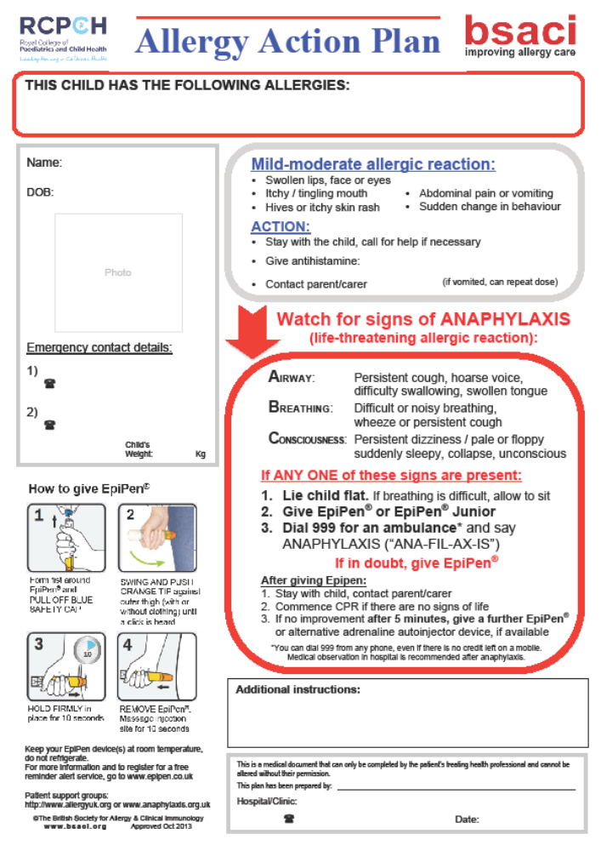

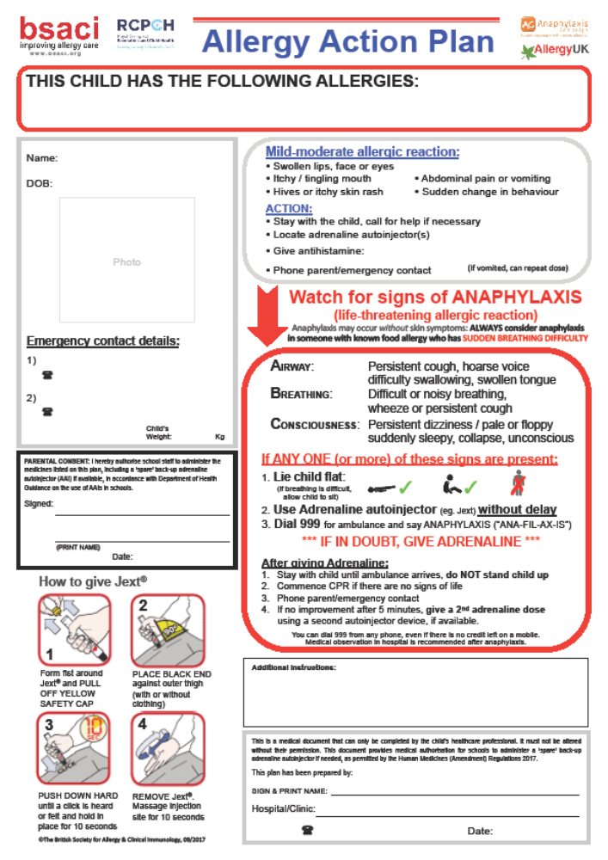

Form 1d - Individual Health Plan - Asthma
For pupils with complex medical needs at school
Date form completed:
Date for review:
Reviewed by | Date  (dd/mm/yyyy) | Changes to Individual Health Plan
 |  | Yes No
 |  | Yes No
 |  | Yes No
Copies held by:
1. Pupil’s Information
Medical Condition:
Name of School:
Name of Pupil:
Class/Form
Date of Birth: |  |  | Male  Female
2. Contact Information
Pupil’s Address |  |  | Postcode:
Family Contact Information
a. | Name
a. | Phone (Day)
a. | Phone (Evening)
a. | Mobile
a. | Relationship with child/young person
b. | Name
b. | Phone (Day)
b. | Phone (Evening)
b. | Mobile
b. | Relationship with child/young person
GP
Name
Phone
Specialist Contact
Name
Phone
Medical Condition Information
3. Details of Pupil’s Medical Conditions
Signs and symptoms of this pupil’s condition:
Triggers or things that make this pupil’s condition/s worse:
4. Routine Healthcare Requirements
(For example, dietary, therapy, nursing needs or before physical activity)
During school hours:
Outside school hours:
5. What to do in an Emergency (Asthma UK Guidelines)
Common signs of an Asthma attack: |  | ˚ Coughing  ˚ Shortness of Breath  ˚ Being unusually quiet |  | ˚ Wheezing  ˚ Tightness in the chest  ˚ Difficulty in speaking full sentences
KEEP CALM – DO NOT PANIC
ENCOURAGE THE CHILD TO SIT UP AND FORWARD – DO NOT HUG THEM OR LIE THEM DOWN
MAKE SURE THE PUPIL TAKES ONE PUFF OF THEIR RELIEVER INHALER (USUALLY BLUE) USING THEIR SPACER
ENSURE TIGHT CLOTHING IS LOOSENED
REASSURE THE PUPIL

ONE PUFF OF THEIR RELIEVER EVERY MINUTE UP TO 10 TIMES, OR UNTIL THEIR SYMPTOMS IMPROVE.

CALL 999 URGENTLY IF:
THEIR SYMPTOMS DO NOT IMPROVE AFTER 10 PUFFS
THEY ARE TOO BREATHLESS TO TALK
THEIR LIPS ARE BLUE OR IF IN ANY DOUBT

CONTINUE TO GIVE 1 PUFF EVERY MINUTE OF THEIR INHALER UNTIL THE AMBULANCE ARRIVES.

Template letter from school nurse to parent/carer

Dear Parent/Carer

Re: The Individual Health Plan

Thank you for informing the school of your child/young person’s medical condition. With advice from the Department for Education and the school’s governing bodies, we are working with schools to follow our shared medical conditions policy.

As part of this policy, we are asking all parents/carers of children/young people with a complex medical need to help us by completing an Individual Health Plan for their child/young person. Please complete the plan enclosed and return it to me at …………. If you would prefer to meet me to complete the Individual Health Plan or if you have any questions then please contact me on [insert school nurse contact number].

Your child/young person’s completed plan will store helpful details about your child/young person’s medical condition, current medication, triggers, individual symptoms and emergency contact numbers. The plan will help school staff to better understand your child/young person’s individual condition.

Please make sure the plan is regularly checked and updated and the school and school nurse are kept informed about changes to your child/young person’s medical condition or medication. This includes any changes to how much medication they need to take and when they need to take it.

Thank you for your help.

Yours sincerely

Form 3a – Medication Permission & Record – Individual Pupil

Form 3a – Medication Permission & Record
– Individual Pupil
Name of School:
Name of Pupil:
Class/Form:
Date medication provided by parent:
Name of medication:
Dose and Method:
(how much and when to take)
When is it taken (time)
Quantity Received:
Expiry Date:
Date and quantity of medication returned to parent:
Any other information:
Staff signature:
Print name:
Parent/Carer Signature:
Print name:
Parent/Carer Contact Number:

Form 3b – Record of Medication
Date | Pupil’s Name | Time | Name of Medication | Dose Given | Any Reactions | Signature of Staff Member | Print Name

Form 4 – Staff Training Record
Name of School:
Type of training received:
Date training completed:
Training provided by:
Trainer Job Title and Profession:

I confirm that the people listed above have received this training
Name of people attending training
1.
2.
3.
4.
5.

Trainer’s Signature:
Date:
Use a separate sheet if more than five people have received training

I confirm that the people listed above have received this training
Headteacher signature:
Print Name:
Date:
Suggested date for update training:

Form 5 - for Visits and Journeys
This form is to be returned by (date):
School or Youth Centre:
Course or Activity
Date of Course/Activity:

Student Details
Surname:
Forename(s):
Date of Birth

Medical Information
 | Please indicate
Does your son/daughter suffer from any illness or physical disability? | Yes  No | If so, please describe:
If medical treatment is required, please describe:
To the best of your knowledge has she/he been in contact with any contagious or infectious disease during the past four weeks? | Yes  No | If so, please give brief details:
Is he/she allergic to any medication: | Yes  No | If so, please give brief details:
*Has your son/daughter received a tetanus injection in the last 5 years? | Yes  No
Please indicate any special dietary requirements due to medical, religious or moral reasons:
* This may have been as part of the routine vaccination programme. Please check either the child’s RED book or GP.

Parental Declaration
I give permission for my daughter/son (insert name) to take part in the above activity as described, including all organised activities.

I undertake to inform the visit organiser or the Headteacher as soon as possible of any relevant change in medical circumstances occurring before the journey.

I hereby authorise any accompanying member of staff of the school to give consent to such medical treatment as is considered necessary for my child/young person by a qualified medical practitioner during the visit.

I understand the extent and limitations of the insurance cover provided.
Contact Information
Address:
Home Telephone No.
Work Telephone No.
Emergency contact address if different from that above
Address:
Tel No.
Name of Family Doctor:
Telephone Nos.
Address:
Signed:
Parent/Guardian

Giving Paracetamol in Stockport Schools

Form 3a should be completed for each child/young person for written permission to give regular paracetamol.

Verbal consent from the parent, carer or young person should be obtained prior to giving a dose of paracetamol to children/young people.

School should seek information from parents/carers about which medicines the child/young person has taken.

NB Paracetamol is an everyday drug, but it is potentially dangerous if too much is taken. Be careful to keep it out of the reach of children.
Many medicines that you can buy for colds or pain contain paracetamol (this information is given on the label). Do not give such medicines to a child/young person at the same time, or four hours before or after giving paracetamol.
If the paracetamol does not seem to be helping the child/young person’s pain, contact the parent or carer for advice. Do not give extra doses of paracetamol.
Write down the time, date and child/young person’s name each time that you give paracetamol and ensure that you do not give too much.
Make sure that the medicines you have at school have not reached the ‘best before’ or ‘use by’ date on the packaging. Give out of date medicines to your pharmacist to dispose of.
The following questions are intended to guide your decision making and prevent paracetamol overdose.

Verbal Consent from Parent/Carer

Name of parent/carer:
Relationship to young person:
Telephone number contacted on:
Date and Time of phone conversation:
Questions to be read out and answered by parent/carer  Has the young person ever had problems with Paracetamol?  If yes, refer to GP |  | YES | NO
Has the young person had any doses of Paracetamol in the last 24 hours, if so at what time and what dose was given?

Leave 4 hours between doses
Has the young person had any other medication that contains Paracetamol in the last 4 hours such as cold or flu remedies?(E.g. Lempsip, Beechams, Calpol).

If yes - do not give any paracetamol
What dose of Paracetamol does the child/young person usually take?

Refer to bottle or label before administering
Parent/Guardian fully aware of what they are consenting to and knows why you wish to give Paracetamol, please state reason

Declaration by the person contacting the parent/carer

I have completed the above assessment questionnaire.
I have assessed there are no contraindications and have administered the Paracetamol.
Time and date …………………………………………………………………………….
Dose………………………………………………………………………………………..
Signature……………………………………………………………………………………

Emergency Procedures

Contacting Emergency Services

Dial 999, ask for an ambulance and be ready with the following information:

1. Your telephone number.
2. Give your location as follows.
3. State the postcode.
4. Give exact location in the school of the person needing help.
5. Give your name.
6. Give the name of the person needing help.
7. Give a brief description of the person’s symptoms (and any known medical condition).
8. Inform ambulance control of the best entrance and state that the crew will be met at this entrance and taken to the pupil.
9. Do not hang up until the information has been repeated back to you.
10. Ideally the person calling should be with the child/young person, as the emergency services may give first aid instruction.
11. Never cancel an ambulance once it has been called.

Speak clearly and slowly

Insert school address and postcode

Put a completed copy of this form by phones around the school

How to Administer BUCCOLAM
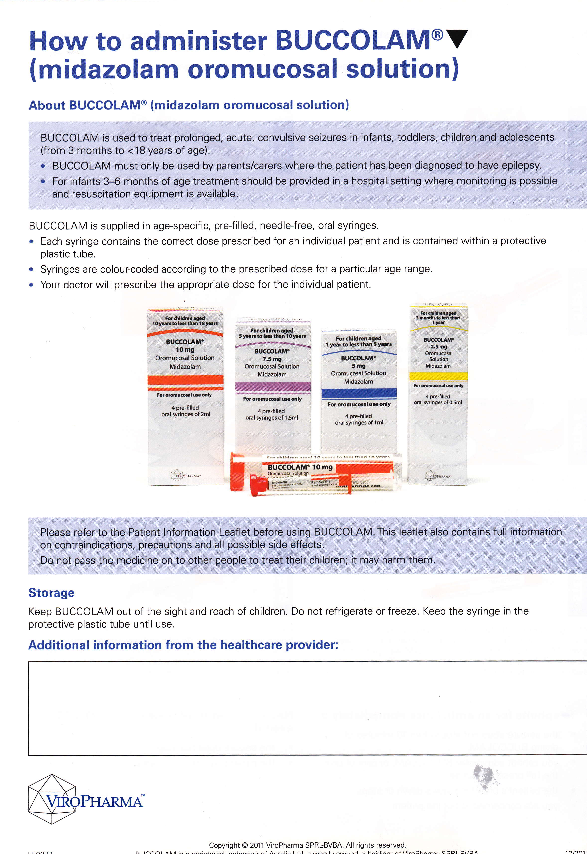
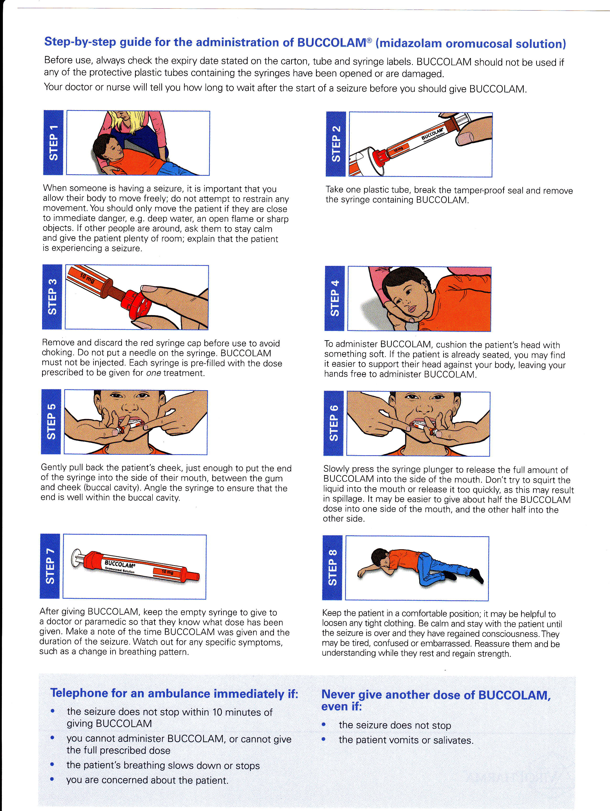

How do I give the Rectal Diazepam?
- Take the tube out of the foil wrapping and remove the safety cap.
- Place the child/young person in a suitable position, for example on their side.
- Insert the nozzle of the tube into their bottom (rectum) up to the end of the tube.
- Whilst inserted, squeeze contents of tube and keep squeezing whilst you withdraw the tube.
- Hold the child/young person's buttocks together for approximately five minutes.
- If the child/young person opens their bowel after you have given the Diazepam, do not repeat the dose straight away, as it will be difficult to know how much has already been absorbed.
- If the seizure continues, call an ambulance and explain what has happened or seek medical advice (Please see the section headed ‘Contact details’).
Does the Rectal Diazepam work immediately?
It can take 5 – 10 minutes for the medicine to be absorbed into
the bloodstream.
Do I need to call an ambulance?
It is advisable to call an ambulance as well as giving the Rectal Diazepam if:
- Stated in the IHP.
- The child/young person appears to be having difficulty breathing.
- This is the first time Rectal Diazepam has been used on the child/young person.
- The seizure has not stopped 10 minutes after using Rectal Diazepam.
- If you think the child/young person has been injured during their seizure.

© Copyright to Central Manchester University Hospitals NHS Foundation Trust

Guidance for schools on the use of emergency Salbutamol inhalers
Primary and secondary schools now have the option of keeping a Salbutamol (Ventolin) inhaler for emergency use.
This is not a formal requirement; schools can decide whether they wish to implement this option and should establish a process for the storage and use of the emergency inhaler (See Medical Conditions in School policy on Office on Line on the link below).
https://scwd.stockport.gov.uk/cypd/content/Forms/forms.aspx?bid=95

School processes should be based on the guidance which can be found at
https://www.gov.uk/government/uploads/system/uploads/attachment_data/file/360585/guidance_on_use_of_emergency_inhalers_in_schools_October_2014.pdf

Parental responsibility
It is important to note that existing policies and procedures are not affected by this additional option. The provision of a full and in date inhaler and spacer is still the parents/carers responsibility.

Use of the emergency inhaler
The emergency Salbutamol inhaler should only be used by children/young people who have either been diagnosed with asthma and prescribed a Salbutamol inhaler or who have been prescribed a Salbutamol inhaler as reliever medication.
The inhaler can be used if the pupil’s prescribed inhaler is not available (for example because it is broken or empty).

Important – new guidance on overuse of reliever inhalers from Asthma UK
Staff should be made aware that a child/young person using their reliever (usually blue) inhaler more than three times a week or suddenly using their reliever inhaler more than they normally do has asthma that may not be under control and may be at greater risk of having an asthma attack. Should this be observed, immediate action should be taken to alert the parents/carers and staff should record any actions or discussions.

Benefits of an emergency inhaler
Keeping an inhaler for emergency use will have many benefits. It could prevent an unnecessary and traumatic trip to hospital for a child/young person and potentially save their life. Parents/carers are likely to have greater peace of mind about sending their child/young person to school. Having a protocol that sets out how and when the inhaler should be used will also protect staff by ensuring they know what to do in the event of a child/young person having an asthma attack.

Purchasing inhalers and spacers
We recommend you contact your local pharmacist to discuss your requirements; staff may also be required to present formal identification at the point of purchase.

Further support and training
Asthma awareness training is available free of charge from your school nurse or from Miranda Galloway on behalf of Asthma UK, email miranda.galloway@stockport.gov.uk

Asthma Emergency Procedures

Common signs of an asthma attack:
+ coughing
+ shortness of breath
+ wheezing
+ feeling tight in the chest
+ being unusually quiet
+ difficulty speaking in full sentences
+ sometimes younger children express feeling tight in the chest and a tummy ache.

Do . . .
+ keep calm
+ encourage the pupil to sit up and slightly forward – do not hug them or lie them down
+ make sure the pupil takes one puff of their reliever inhaler (usually blue) immediately – preferably through a spacer
+ ensure tight clothing is loosened
+ reassure the pupil.

If there is no immediate improvement
+ Continue with reliever inhaler one puff every minute for 10 minutes.

999
Call an ambulance urgently if any of the following:
+ the pupil’s symptoms do not improve after 10 puffs
+ the pupil is too breathless or exhausted to talk
+ the pupil’s lips are blue
+ you are in any doubt.

Ensure the pupil takes one puff of their reliever inhaler every minute until the ambulance arrives.

After a minor asthma attack
+ Minor attacks should not interrupt the involvement of a pupil with asthma in school.
When the pupil feels better they can return to school activities.
+ The parents/carers must always be told if their child/young person has had an asthma attack.

Important things to remember in an asthma attack

+ Never leave a pupil having an asthma attack.
+ If the pupil does not have their inhaler and/or spacer with them, send another teacher or pupil to their classroom or assigned room to get their spare inhaler and/or spacer.
+ In an emergency situation school staff are required under common law, duty of care, to act like any reasonably prudent parent.
+ Reliever medicine is very safe. During an asthma attack do not worry about a pupil overdosing.
+ Send a pupil to get another teacher/adult if an ambulance needs to be called.
+ Contact the pupil’s parents/carers immediately after calling the ambulance.
+ A member of staff should always accompany a pupil taken to hospital by ambulance and stay with them until their parent arrives.
+ Generally staff should not take pupils to hospital in their own car.

Do not cancel an ambulance once called, even if the pupil’s condition appears to have improved.

Anaphylaxis Emergency Procedures

Anaphylaxis has a whole range of symptoms

Any of the following may be present, although most pupils with anaphylaxis would not necessarily experience all of these:

+ generalised flushing of the skin anywhere on the body
+ nettle rash (hives) anywhere on the body
+ difficulty in swallowing or speaking
+ swelling of throat and mouth
+ alterations in heart rate
+ signs of breathlessness and/or severe asthma symptoms (see asthma section for more details)
+ abdominal pain, nausea and vomiting
+ sense of impending doom
+ sudden feeling of weakness (due to a drop in blood pressure)
+ collapse and unconsciousness.

Do
If a pupil with allergies shows any possible symptoms of a reaction, immediately seek help from a member of staff trained in anaphylaxis emergency procedures. Ensure all members of staff know who is trained.

The trained member of staff should:
+ assess the situation
+ follow the pupil’s emergency procedure closely. These instructions will have been given by the paediatrician/healthcare professional during the staff training session and/or the protocol written by the pupil’s doctor
+ administer appropriate medication in line with perceived symptoms.

999
If they consider that the pupil’s symptoms are cause for concern, call for an ambulance
State:
+ the name and age of the pupil
+ that you believe them to be suffering from anaphylaxis
+ the cause or trigger (if known)
+ the name, address and telephone number of the school
+ call the pupil’s parents/carers.
While awaiting medical assistance the designated trained staff should:
+ continue to assess the pupil’s condition
+ position the pupil in the most suitable position according to their symptoms.

Symptoms and the position of pupil
+ If the pupil is feeling faint or weak, looking pale, or beginning to go floppy, lay them down with their legs raised. They should NOT stand up.
+ If there are also signs of vomiting, lay them on their side to avoid choking.
+ If they are having difficulty breathing caused by asthma symptoms or by swelling of the airways they are likely to feel more comfortable sitting up.

Do
+ If symptoms are potentially life-threatening, give the pupil their adrenaline injector into the outer aspect of their thigh. Make sure the used injector is made safe before giving it to the ambulance crew. Either put it in a rigid container or follow the instructions given at the anaphylaxis training.
+ Make a note of the time the adrenaline is given in case a second dose is required and also to notify the ambulance crew.
+ On the arrival of the paramedics or ambulance crew the staff member in charge should inform them of the time and type of medicines given. All used adrenaline injectors must be handed to the ambulance crew.

After the emergency
+ After the incident carry out a debriefing session with all members of staff involved.
+ Parents/carers are responsible for replacing any used medication.

Do not cancel an ambulance once called, even if the pupil’s condition appears to have improved.

Diabetes Emergency Procedures

Hyperglycaemia
If a pupil’s blood glucose level is high (over 10mmol/l) and stays high.

Common symptoms:
+ thirst
+ frequent urination
+ tiredness
+ dry skin
+ nausea
+ blurred vision.

Do . . .
Call the pupil’s parents/carers who may request that extra insulin be given.
The pupil may feel confident to give extra insulin.

999
If the following symptoms are present, then call the emergency services:
+ deep and rapid breathing (over-breathing)
+ vomiting
+ breath smelling of nail polish remover.

Hypoglycaemia

What causes a hypo?
+ too much insulin
+ a delayed or missed meal or snack
+ not enough food, especially carbohydrate
+ unplanned or strenuous exercise
+ drinking large quantities of alcohol or alcohol without food
+ no obvious cause.

Watch out for:
+ hunger
+ trembling or shakiness
+ sweating
+ anxiety or irritability
+ fast pulse or palpitations
+ tingling

+ glazed eyes
+ pallor
+ mood change, especially angry or aggressive behaviour
+ lack of concentration
+ vagueness
+ drowsiness.

Do
Immediately give something sugary, a quick-acting carbohydrate such as one of the following:

+ a glass of Lucozade, coke or other non-diet drink
+ three or more glucose tablets
+ a glass of fruit juice
+ five sweets, e.g. jelly babies
+ GlucoGel.

The exact amount needed will vary from person to person and will depend on individual needs and circumstances.

After 10 – 15 minutes recheck the blood sugar again. If it is below 4 give another sugary quick acting carbohydrate.

This will be sufficient for a pump user but for pupils who inject insulin a longer-acting carbohydrate will be needed to prevent the blood glucose dropping again.

+ roll/sandwich
+ portion of fruit
+ one individual mini pack of dried fruit
+ cereal bar
+ two biscuits, e.g. garibaldi, ginger nuts
+ or a meal if it is due.

If the pupil still feels hypo after 15 minutes, something sugary should again be given. When the child/young person has recovered, give them some starchy food, as above.

999

If the pupil is unconscious do not give them anything to eat or drink; call for an ambulance and contact their parents/carers.

Epilepsy Emergency Procedures

First aid for seizures is quite simple, and can help prevent a child/young person from being harmed by a seizure. First aid will depend on the individual child/young person’s epilepsy and the type of seizure they are having. Some general guidance is given below, but most of all it is important to keep calm and know where to find help.

Tonic-clonic seizures

Symptoms:
+ the person loses consciousness, the body stiffens, then falls to the ground
+ this is followed by jerking movements
+ a blue tinge around the mouth is likely, due to irregular breathing
+ loss of bladder and/or bowel control may occur
+ after a minute or two the jerking movements should stop and consciousness slowly returns.

Do . . .
+ protect the person from injury – (remove harmful objects from nearby)
+ cushion their head
+ look for an epilepsy identity card or identity jewellery. These may give more information about a pupil’s condition, what to do in an emergency, or a phone number for advice on how to help
+ once the seizure has finished, gently place them in the recovery position to aid breathing
+ keep calm and reassure the person
+ stay with the person until recovery is complete.

Don’t . . .
+ restrain the pupil
+ put anything in the pupil’s mouth
+ try to move the pupil unless they are in danger
+ give the pupil anything to eat or drink until they are fully recovered.
+ attempt to bring them round.

999
Call for an ambulance if . . .
+ you believe it to be the pupil’s first seizure
+ the seizure continues for more than five minutes
+ one tonic-clonic seizure follows another without the person regaining consciousness between seizures
+ the pupil is injured during the seizure
+ you believe the pupil needs urgent medical attention.

Seizures involving altered consciousness or behaviour

Simple partial seizures
Symptoms:
+ twitching
+ numbness
+ sweating
+ dizziness or nausea
+ disturbances to hearing, vision, smell or taste
+ a strong sense of deja-vu.

Complex partial seizures
Symptoms:
+ plucking at clothes
+ smacking lips, swallowing repeatedly or wandering around
+ the person is not aware of their surroundings or of what they are doing.

Atonic seizures
Symptoms:
+ sudden loss of muscle control causing the person to fall to the ground. Recovery is quick.

Myoclonic seizures
Symptoms:
+ brief forceful jerks which can affect the whole body or just part of it
+ the jerking could be severe enough to make the person fall.

Absence seizures
Symptoms:
+ the person may appear to be daydreaming or switching off. They are momentarily unconscious and totally unaware of what is happening around them.

Do . . .
+ guide the person away from danger
+ look for an epilepsy identity card or identity jewellery. These may give more information about a person’s condition, what to do in an emergency, or a phone number for advice on how to help.
+ stay with the person until recovery is complete
+ keep calm and reassure the person
+ explain anything that they may have missed.

Don’t . . .
+ restrain the person
+ act in a way that could frighten them, such as making abrupt movements or shouting at them
+ assume the person is aware of what is happening, or what has happened
+ give the person anything to eat or drink until they are fully recovered
+ attempt to bring them round.

999
Call for an ambulance if . . .
+ one seizure follows another without the person regaining awareness between them
+ the person is injured during the seizure
+ you believe the person needs urgent medical attention.

Do not cancel an ambulance once called, even if the pupil’s condition appears to have improved.

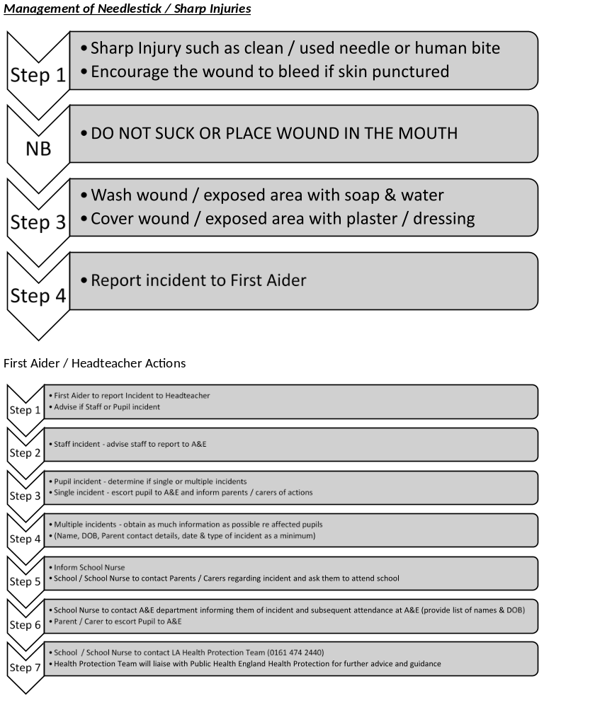

Guidance on Infection Control in
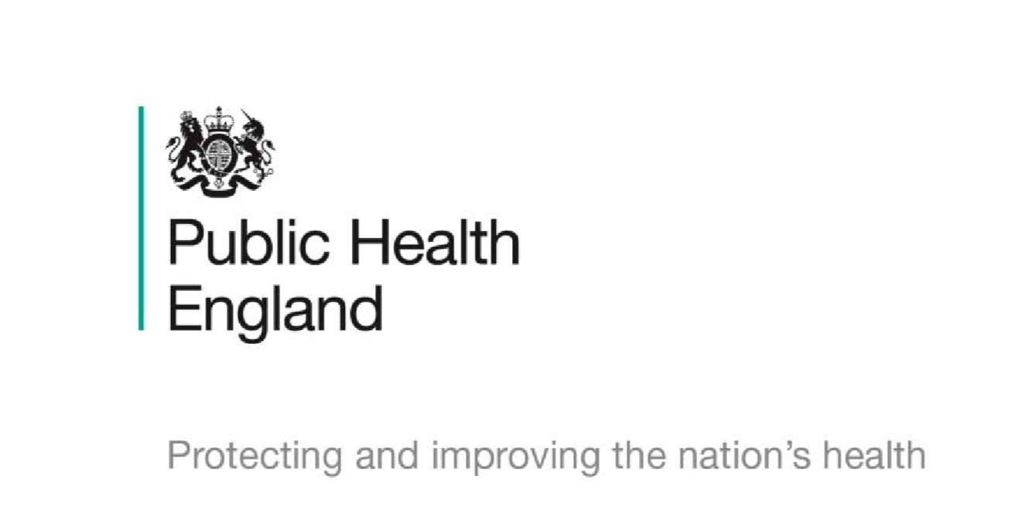
Schools and other Childcare Settings

About Public Health England
Public Health England exists to protect and improve the nation's health and wellbeing, and reduce health inequalities. It does this through world-class science, knowledge and intelligence, advocacy, partnerships and the delivery of specialist public health services. PHE is an operationally autonomous executive agency of the Department of Health.

Public Health England
Wellington House
133-155 Waterloo Road
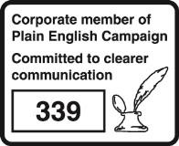
London SE1 8UG Tel: 020 7654 8000 www.gov.uk/phe Twitter: @PHE_uk
Facebook: www.facebook.com/PublicHealthEngland

Prepared by: Mamoona Tahir. Information produced with the assistance of the Royal College of Paediatrics and Child Health.

For queries relating to this document, please contact mamoona.tahir@phe.gov.uk

© Crown copyright 2016
You may re-use this information (excluding logos) free of charge in any format or medium, under the terms of the Open Government Licence v3.0. To view this licence, visit OGL or email psi@nationalarchives.gsi.gov.uk. Where we have identified any third party copyright information you will need to obtain permission from the copyright holders concerned.

First published: September 2014
This version: May 2016
PHE publications gateway number: 2014006

Contents
About Public Health England 85
1. Introduction 87
2. Rashes and skin infections 88
3. Diarrhoea and vomiting illness 89
4. Respiratory infections 89
5. Other infections 90
6. Good hygiene practice 92
Handwashing 92
Coughing and sneezing 92
Personal protective equipment (PPE) 92
Cleaning of the environment 92
Cleaning of blood and body fluid spillages 92
Laundry 92
Clinical waste 92
Sharps disposal 93
Sharps injuries and bites 93
Animals 93
Animals in school (permanent or visiting) 93
Visits to farms 93
Vulnerable children 93
Female staff – pregnancy 93
7. Immunisations 94
Immunisation schedule 94
Appendix 1. PHE centre contact details 95

1. Introduction
The document provides guidance for schools and other childcare settings, such as nurseries, on infection control issues.

It is an updated version of guidance that was produced in 2010.

Prevent the spread of infections by ensuring:

- routine immunisation
- high standards of personal hygiene and practice, particularly handwashing
- maintaining a clean environment

For further information and advice visit www.gov.uk/phe or contact your local health PHE centre. See Appendix 1 for contact details.

2. Rashes and skin infections
Children with rashes should be considered infectious and assessed by their doctor.

Infection or complaint | Recommended period to be kept away from school, nursery or childminders | Comments
Athlete’s foot | None | Athlete’s foot is not a serious condition.  Treatment is recommended
Chickenpox | Until all vesicles have crusted over | See: Vulnerable Children and Female Staff – Pregnancy
Cold sores,  (Herpes simplex) | None | Avoid kissing and contact with the sores. Cold sores are generally mild and self-limiting
German measles  (rubella)* | Four days from onset of rash (as per “Green Book”) | Preventable by immunisation (MMR x2 doses). See: Female Staff – Pregnancy
Hand, foot and mouth | None | Contact your local HPT if a large number of children are affected. Exclusion may be considered in some circumstances
Impetigo | Until lesions are crusted and healed, or 48 hours after starting antibiotic treatment | Antibiotic treatment speeds healing and reduces the infectious period
Measles* | Four days from onset of rash | Preventable by vaccination (MMR x2). See:  Vulnerable Children and Female Staff – Pregnancy
Molluscum contagiosum | None | A self-limiting condition
Ringworm | Exclusion not usually required | Treatment is required
Roseola (infantum) | None | None
Scabies | Child can return after first treatment | Household and close contacts require treatment
Scarlet fever* | Child can return 24 hours after starting appropriate antibiotic treatment | Antibiotic treatment is recommended for the affected child
Slapped cheek/fifth disease. Parvovirus B19 | None (once rash has developed) | See: Vulnerable Children and Female Staff – Pregnancy
Shingles | Exclude only if rash is weeping and cannot be covered | Can cause chickenpox in those who are not immune, ie have not had chickenpox. It is spread by very close contact and touch. If further information is required, contact your local PHE centre. See: Vulnerable Children and Female Staff – Pregnancy
Warts and verrucae | None | Verrucae should be covered in swimming pools, gymnasiums and changing rooms

3. Diarrhoea and vomiting illness
Infection or complaint | Recommended period to be kept away from school, nursery or childminders | Comments
Diarrhoea and/or vomiting | 48 hours from last episode of diarrhoea or vomiting
E. coli O157 VTEC Typhoid* [and paratyphoid*] (enteric fever)  Shigella  (dysentery) | Should be excluded for 48 hours from the last episode of diarrhoea. Further exclusion may be required for some children until they are no longer excreting | Further exclusion is required for children aged five years or younger and those who have difficulty in adhering to hygiene practices. Children in these categories should be excluded until there is evidence of  microbiological clearance. This guidance may also apply to some contacts who may also require microbiological clearance. Please consult your local PHE centre for further advice
Cryptosporidiosis | Exclude for 48 hours from the last episode of diarrhoea | Exclusion from swimming is advisable for two weeks after the diarrhoea has settled

4. Respiratory infections
Infection or complaint | Recommended period to be kept away from school, nursery or childminders | Comments
Flu (influenza) | Until recovered | See: Vulnerable Children
Tuberculosis* | Always consult your local PHE centre | Requires prolonged close contact for spread
Whooping cough*  (pertussis) | Five days from starting antibiotic treatment, or 21 days from onset of illness if no antibiotic treatment | Preventable by vaccination. After treatment, non-infectious coughing may continue for many weeks. Your local PHE centre will organise any contact tracing necessary

5. Other infections
Infection or complaint | Recommended period to be kept away from school, nursery or child minders | Comments
Conjunctivitis | None | If an outbreak/cluster occurs, consult your local PHE centre
Diphtheria * | Exclusion is essential. Always consult with your local HPT | Family contacts must be excluded until cleared to return by your local PHE centre. Preventable by vaccination. Your local PHE centre will organise any contact tracing necessary
Glandular fever | None
Head lice | None | Treatment is recommended only in cases where live lice have been seen
Hepatitis A* | Exclude until seven days after onset of jaundice (or seven days after symptom onset if no jaundice) | In an outbreak of hepatitis A, your local PHE centre will advise on control measures
Hepatitis B*, C*, HIV/AIDS | None | Hepatitis B and C and HIV are bloodborne viruses that are not infectious through casual contact. For cleaning of body fluid spills see: Good Hygiene Practice
Meningococcal meningitis*/ septicaemia* | Until recovered | Meningitis C is preventable by vaccination There is no reason to exclude siblings or other close contacts of a case. In case of an outbreak, it may be necessary to provide antibiotics with or without meningococcal vaccination to close school contacts. Your local PHE centre will advise on any action is needed
Meningitis* due to other bacteria | Until recovered | Hib and pneumococcal meningitis are preventable by vaccination. There is no reason to exclude siblings or other close contacts of a case. Your local PHE centre will give advice on any action needed
Meningitis viral* | None | Milder illness. There is no reason to exclude siblings and other close contacts of a case. Contact tracing is not required
MRSA | None | Good hygiene, in particular handwashing and environmental cleaning, are important to minimise any danger of spread. If further information is required, contact your local PHE centre
Mumps* | Exclude child for five days after onset of swelling | Preventable by vaccination (MMR x2 doses)
Threadworms | None | Treatment is recommended for the child and household contacts
Tonsillitis | None | There are many causes, but most cases are due to viruses and do not need an antibiotic

* denotes a notifiable disease. It is a statutory requirement that doctors report a notifiable disease to the proper officer of the local authority (usually a consultant in communicable disease control). In addition, organisations may be required via locally agreed arrangements to inform their local PHE centre. Regulating bodies (for example, Office for Standards in Education (OFSTED)/Commission for Social Care Inspection (CSCI)) may wish to be informed – please refer to local policy.

Outbreaks: if an outbreak of infectious disease is suspected, please contact your local PHE centre.

6. Good hygiene practice

Handwashing
Handwashing is one of the most important ways of controlling the spread of infections, especially those that cause diarrhoea and vomiting, and respiratory disease. The recommended method is the use of liquid soap, warm water and paper towels. Always wash hands after using the toilet, before eating or handling food, and after handling animals. Cover all cuts and abrasions with waterproof dressings.

Coughing and sneezing
Coughing and sneezing easily spread infections. Children and adults should be encouraged to cover their mouth and nose with a tissue. Wash hands after using or disposing of tissues. Spitting should be discouraged.

Personal protective equipment (PPE)
Disposable non-powdered vinyl or latex-free CE-marked gloves and disposable plastic aprons must be worn where there is a risk of splashing or contamination with blood/body fluids (for example, nappy or pad changing). Goggles should also be available for use if there is a risk of splashing to the face. Correct PPE should be used when handling cleaning chemicals.

Cleaning of the environment
Cleaning of the environment, including toys and equipment, should be frequent, thorough and follow national guidance. For example, use colour-coded equipment, COSHH and correct decontamination of cleaning equipment. Monitor cleaning contracts and ensure cleaners are appropriately trained with access to PPE.

Cleaning of blood and body fluid spillages
All spillages of blood, faeces, saliva, vomit, nasal and eye discharges should be cleaned up immediately (always wear PPE). When spillages occur, clean using a product that combines both a detergent and a disinfectant. Use as per manufacturer’s instructions and ensure it is effective against bacteria and viruses and suitable for use on the affected surface. Never use mops for cleaning up blood and body fluid spillages – use disposable paper towels and discard clinical waste as described below. A spillage kit should be available for blood spills.

Laundry
Laundry should be dealt with in a separate dedicated facility. Soiled linen should be washed separately at the hottest wash the fabric will tolerate. Wear PPE when handling soiled linen. Children’s soiled clothing should be bagged to go home, never rinsed by hand.

Clinical waste
Always segregate domestic and clinical waste, in accordance with local policy. Used nappies/pads, gloves, aprons and soiled dressings should be stored in correct clinical waste bags in foot-operated bins. All clinical waste must be removed by a registered waste contractor. All clinical waste bags should be less than two-thirds full and stored in a dedicated, secure area while awaiting collection.

Sharps disposal
Sharps should be discarded straight into a sharps bin conforming to BS 7320 and UN 3291 standards. Sharps bins must be kept off the floor (preferably wall-mounted) and out of reach of children.

Sharps injuries and bites
If skin is broken, encourage the wound to bleed/ wash thoroughly using soap and water. Contact GP or occupational health or go to A&E immediately. Ensure local policy is in place for staff to follow. Contact your local HPT for advice, if unsure.

Animals
Animals may carry infections, so hands must be washed after handling any animals. Health and Safety Executive (HSE) guidelines for protecting the health and safety of children should be followed.

Animals in school (permanent or visiting)
Ensure animals’ living quarters are kept clean and away from food areas. Waste should be disposed of regularly, and litter boxes not accessible to children. Children should not play with animals unsupervised. Veterinary advice should be sought on animal welfare and animal health issues and the suitability of the animal as a pet. Reptiles are not suitable as pets in schools and nurseries, as all species carry salmonella.

Visits to farms
Please contact your local environmental health department, which will provide you with help and advice when you are planning a visit to a farm or similar establishment. For more information see http://www.face-online.org.uk/resources/preventing-or-controllingill-health-from-animal-contact-at-visitor-attractions-industry-code-of-practice

Vulnerable children
Some medical conditions make children vulnerable to infections that would rarely be serious in most children, these include those being treated for leukaemia or other cancers, on high doses of steroids and with conditions that seriously reduce immunity. Schools and nurseries and childminders will normally have been made aware of such children. These children are particularly vulnerable to chickenpox, measles or parvovirus B19 and, if exposed to either of these, the parent/carer should be informed promptly and further medical advice sought. It may be advisable for these children to have additional immunisations, for example pneumococcal and influenza.

Female staff – pregnancy
If a pregnant woman develops a rash or is in direct contact with someone with a potentially infectious rash, this should be investigated according to PHE guidelines by a doctor. The greatest risk to pregnant women from such infections comes from their own child/children, rather than the workplace. Some specific risks are:

- chickenpox can affect the pregnancy if a woman has not already had the infection. Report exposure to midwife and GP at any stage of exposure. The GP and antenatal carer will arrange a blood test to check for immunity. Shingles is caused by the same virus as chickenpox, so anyone who has not had chickenpox is potentially vulnerable to the infection if they have close contact with a case of shingles
- German measles (rubella). If a pregnant woman comes into contact with german measles she should inform her GP and antenatal carer immediately to ensure investigation. The infection may affect the developing baby if the woman is not immune and is exposed in early pregnancy
- slapped cheek disease (parvovirus B19) can occasionally affect an unborn child. If exposed early in pregnancy (before 20 weeks), inform whoever is giving antenatal care as this must be investigated promptly
- measles during pregnancy can result in early delivery or even loss of the baby. If a pregnant woman is exposed she should immediately inform whoever is giving antenatal care to ensure investigation

This advice also applies to pregnant students.

7. Immunisations
Immunisation status should always be checked at school entry and at the time of any vaccination. Parents should be encouraged to have their child immunised and any immunisation missed or further catch-up doses organised through the child’s GP. For the most up-to-date immunisation advice see the NHS Choices website at www.nhs.uk or the school health service can advise on the latest national immunisation schedule.

Immunisation schedule
Two months old | Diphtheria, tetanus, pertussis, polio and Hib  (DTaP/IPV/Hib)  Pneumococcal (PCV13)  Rotavirus vaccine | One injection  One injection  Given orally
Three months old | Diphtheria, tetanus, pertussis, polio and Hib  (DTaP/IPV/Hib)  Meningitis C (Men C)  Rotavirus vaccine | One injection  One injection  Given orally
Four months old | Diphtheria, tetanus, pertussis, polio and Hib  (DTaP/IPV/Hib)  Pneumococcal (PCV13) | One injection  One injection
Between 12-13 months old | Hib/meningitis C  Measles, mumps and rubella (MMR) Pneumococcal (PCV13) | One injection  One injection  One injection
Two, three and four years old | Influenza (from September) | Nasal spray or one injection
Three years and four months old or soon after | Diphtheria, tetanus, pertussis, polio (DTaP/IPV or dTaP/IPV)  Measles, mumps and rubella (MMR) | One injection  One injection
Girls aged 12 to 13 years | Cervical cancer caused by human papilloma virus types 16 and 18. HPV vaccine | Two injections given 6-24 months apart
Around 14 years old | Tetanus, diphtheria, and polio (Td/IPV) | One injection
Around 14 years old | Meningococcal C (Men C) | One injection

This is the complete routine immunisation schedule. Children who present with certain risk factors may require additional immunisations. Some areas have local policies – check with your local PHE centre.

Staff immunisations – all staff should undergo a full occupational health check before starting employment; this includes ensuring they are up to date with immunisations, including MMR.

Appendix 1. PHE centre contact details

North of England

Cheshire and Merseyside PHE Centre
5th Floor
Rail House
Lord Nelson Street
Liverpool L1 1JF
Tel: 0344 225 1295

Cumbria and Lancashire PHE Centre
1st Floor, York House
Ackhurst Business Park
Foxhole Road
Chorley PR7 1NY
Tel: 0344 225 0602

Greater Manchester PHE Centre
5th Floor
3 Piccadilly Place
London Road
Manchester M1 3BN
Tel: 0344 225 0562

North East PHE Centre
Floor 2 Citygate
Gallowgate
Newcastle-upon-Tyne NE1 4WH
Tel: 0300 303 8596

Yorkshire and the Humber PHE Centre
Blenheim House
West One
Duncombe Street
Leeds LS1 4PL
Tel: 0113 386 0300

Midlands and East of England

Anglia and Essex PHE Centre
Eastbrook
Shaftesbury Road
Cambridge CB2 8DF
Tel: 0303 444 6690

East Midlands PHE Centre
Institute of Population Health
Nottingham City Hospital
Hucknall Road
Nottingham NG5 1QP
Tel: 0344 225 4524

South Midlands and Hertfordshire PHE Centre
Beacon House
Dunhams Lane
Letchworth Garden City
Herts SG6 1BE
Tel: 0300 303 8537

West Midlands PHE Centre
6th Floor
5 St Philip's Place
Birmingham B3 2PW
Tel: 0344 225 3560

South of England

Avon, Gloucestershire and Wiltshire PHE Centre
2 Rivergate
Temple Quay
Bristol BS1 6EH
Tel: 0300 303 8162

Devon, Cornwall and Somerset PHE Centre
Richmond Court
Emperor Way
Exeter Business Park
Exeter
Devon EX1 3QS
Tel: 0344 225 3557
Kent, Surrey and Sussex PHE Centre
County Hall North
Chart Way
Horsham
West Sussex RH12 1XA
Tel: 0344 225 3861

Thames Valley PHE Centre
Chilton
Oxfordshire
OX11 0RQ
Tel: 0345 279 9879

Wessex PHE Centre
Unit 8, Fulcrum 2
Solent Way
Fareham
Hampshire PO15 7FN
Tel: 0345 055 2022

London

London integrated region and PHE Centre
151 Buckingham Palace Road
London SW1W 9SZ
Tel: 020 7811 7000/7001

